Announcement regarding harshment (safety information) in the Physician Leaflet (PI)

הודעה על החמרה ( מידע בטיחות) בעלון לרופא

תאריך01/03/2012
Name of the product:
שם תכשיר באנגלית:
ARANESP® 10, 20, 30, 40, 50, 60, 80, 100, 150, 300, 500 µg
Solution for Injection
Registration No's:
מספר רישום:
Aranesp 10 | 1243830392 00
Aranesp 20 | 1244030394 00
Aranesp 30 | 1244130395 00
Aranesp 40 | 1244230396 00
Aranesp 50 | 1244330397 00
Aranesp 60 | 1244430398 00
Aranesp 80 | 1244530399 00
Aranesp 100 | 1244630400 00
Aranesp 150 | 1244730401 00
Aranesp 300 | 1296530888 00
Aranesp 500 | 1333231237 00
Name of the registration owner: Amgen Europe B.V. שם בעל הרישום_

Details regarding the requested changes
פרטים על השינוי/ים המבוקש/ים
Chapter in leaflet  פרק בעלון | Current text  טקסט נוכחי | New text  טקסט חדש
3. PHARMACEUTICAL FORM | Posology and Method of Administration | ARANESP® treatment should be initiated by physicians experienced in the above mentioned indications.  ARANESP® is supplied ready for use in a pre-filled syringe or pre-filled pen(Sure-Click).  The pre-filled pen is only for subcutaneous administration.The instructions for use, handling and disposal are given in section special precautions for disposal  Treatment of Symptomatic Anaemia in Chronic Renal Failure Patients  In controlled trials, patients experienced greater risks for death, serious adverse cardiovascular reactions,and stroke when administered erythropoiesis-stimulating agents (ESAs) to target a hemoglobin level of greater than 11 g/dL. No trial has identified a hemoglobin target level, Aranesp dose, or dosing strategy that does not increase these risks. Individualize dosing and use the lowest dose of Aranesp sufficient to reduce theneed for RBC transfusions [see Warnings and Precautions ]. Physicians and patients should weigh thepossible benefits of decreasing transfusions against the increased risks of death and other serious cardiovascular adverse events  Anaemia symptoms and sequelae may vary with age, gender, and overall burden of disease; a physician’s evaluation of the individual patient’s clinical course and condition is necessary. ARANESP® should be administered either subcutaneously or intravenously in order to increase haemoglobin to not greater than 11 g/dl. Subcutaneous use is preferable in patients who are not receiving haemodialysis to avoid the puncture of peripheral veins.  For patients with Chronic Renal Failure on dialysis:  • Initiate Aranesp treatment when the hemoglobin level is less than 10 g/dL.  • If the hemoglobin level approaches or exceeds 11 g/dL, reduce or interrupt the dose of Aranesp  . For patients with Chronic Renal Failure not on dialysis:  • Consider initiating Aranesp treatment only when the hemoglobin level is less than 10 g/dL and the following considerations apply:  o The rate of hemoglobin decline indicates the likelihood of requiring a RBC transfusion and,reducing the risk of alloimmunization and/or other RBC transfusion-related risks is a goal.  • If the hemoglobin level exceeds 10 g/dL, reduce or interrupt the dose of Aranesp, and use the lowest dose of Aranesp sufficient to reduce the need for RBC transfusions.  Due to intra-patient variability, occasional individual haemoglobin values for a patient above and below the desired haemoglobin level may be observed. Haemoglobin variability should be addressed through dose management, with consideration for the haemoglobin target range of 10 g/dl (6.2 mmol/l) to 11 g/dl. A sustained haemoglobin level of greater than 11 g/dl.) should be avoided; guidance for appropriate dose adjustment for when haemoglobin values exceeding 11 g/dl. are observed are described below.  A rise in haemoglobin of greater than 2 g/dl (1.25 mmol/l) over a four week period, should be avoided. If it occurs, appropriate dose adjustment should be made as provided.  Treatment with ARANESP® is divided into two stages – correction and maintenance phase:  Correction phase  The initial ARANESP® dosage by subcutaneous or intravenous administration is 0.45 µg/kg body weight, as a single injection once weekly. Alternatively, in patients not on dialysis, an initial dose of 0.75 μg/kg may be administered subcutaenously as a single injection once every two weeks. If the increase in haemoglobin is inadequate (less than 1 g/dl (0.6 mmol/l) in four weeks) increase the dose by approximately 25%. Dose increases must not be made more frequently than once every four weeks.  If the rise in haemoglobin is greater than 2 g/dl (1.25 mmol/l) in four weeks reduce the ARANESP® dose by approximately 25%. If the haemoglobin exceeds 11 g/dl., a dose reduction should be considered. If the haemoglobin continues to increase, the dose should be reduced by approximately 25%. If after a dose reduction, haemoglobin continues to increase, the dose should be temporarily withheld until the haemoglobin begins to decrease, at which point therapy should be reinitiated at approximately 25% lower than the previous dose.  The haemoglobin should be measured every one or two weeks until it is stable. Thereafter the haemoglobin can be measured at longer intervals.  Maintenance phase  In the maintenance phase, ARANESP® may continue to be administered as a single injection once weekly or once every two weeks. Dialysis patients converting from weekly to once every other week dosing with ARANESP® should initially receive a dose equivalent to twice the previous once weekly dose. In patients not on dialysis, once the target hemoglobin has been achieved with once every two week dosing, ARANESP® may be administered subcutaneously once monthly using an initial dose equal to twice the previous once every two week dose.  Dosing should be titrated as necessary to maintain the haemoglobin target.  If a dose adjustment is required to maintain haemoglobin at the desired level, it is recommended that the dose of ARANESP® is adjusted by approximately 25%.  If the rise in haemoglobin is greater than 2 g/dl (1.25 mmol/l) in four weeks reduce the dose by approximately 25%, depending on the rate of increase. If the haemoglobin 11 g/dl., a dose reduction should be considered. If the haemoglobin continues to increase, the dose should be reduced by approximately 25%. If after a dose reduction, haemoglobin continues to increase, the dose should be temporarily withheld until the haemoglobin begins to decrease, at which point therapy should be reinitiated at approximately 25% lower than the previous dose.  Patients should be monitored closely to ensure that the lowest approved dose of ARANESP® is used to provide adequate control of the symptoms of anaemia.  After any dose or schedule adjustment the haemoglobin should be monitored every one or two weeks. Dose changes in the maintenance phase of treatment should not be made more frequently than every two weeks.  When changing the route of administration the same dose must be used and the haemoglobin monitored every one or two weeks so that the appropriate ARANESP® dose adjustments can be made to keep the haemoglobin at the desired level.  Clinical studies have demonstrated that patients receiving r-HuEPO one, two or three times weekly may be converted to once weekly or once every other week ARANESP® The initial weekly dose of ARANESP® (µg/week) can be determined by dividing the total weekly dose of r-HuEPO (IU/week) by 200. The initial every other week dose of ARANESP® (μg/every other week) can be determined by dividing the total cumulative dose of r-HuEPO administered over a two-week period by 200. Because of individual variability, titration to optimal therapeutic doses is expected for individual patients. When substituting ARANESP® for r-HuEPO the haemoglobin should be monitored every one or two weeks and the same route of administration should be used.  Treatment of Symptomatic Chemotherapy Induced Anaemia in Cancer Patients  ARANESP® should be administered by the subcutaneous route to patients with anaemia (e.g haemoglobin concentration ≤ 10 g/dl (6.2 mmol/l) in order to increase haemoglobin to not greater than 11 g/dl. Anaemia symptoms and sequelae may vary with age, gender, and overall burden of disease; a physician’s evaluation of the individual patient’s clinical course and condition is necessary.  Due to intra-patient variability, occasional individual haemoglobin values for a patient above and below the desired haemoglobin level may be observed. Haemoglobin variability should be addressed through dose management, with consideration for the haemoglobin target range of 10 g/dl (6.2 mmol/l) to 11 g/dl. A sustained haemoglobin level of greater than 11 g/dl. should be avoided; guidance for appropriate dose adjustments for when haemoglobin values exceeding 11 g/dl. are observed are described below.  The recommended initial dose is 500 μg (6.75 μg/kg) given once every three weeks, or once weekly dosing can be given at 2.25 μg/kg body weight. If the clinical response of the patient (fatigue, hemoglobin response) is inadequate after nine weeks, further therapy may not be effective.  ARANESP® therapy should be discontinued approximately four weeks after the end of chemotherapy.  Once the therapeutic objective for an individual patient has been achieved, the dose should be reduced by 25 to 50% in order to ensure that the lowest approved dose of ARANESP® is used to maintain haemoglobin at a level that controls the symptoms of anaemia. Appropriate dose titration between 500 μg, 300 μg, and 150 μg should be considered.  Patients should be monitored closely, if the haemoglobin exceeds 11 g/dl. the dose should be reduced by approximately 25 to 50%. Treatment with ARANESP® should be temporarily discontinued if haemoglobin levels exceed 13 g/dl (8.1 mmol/l). Therapy should be reinitiated at approximately 25% lower than the previous dose after haemoglobin levels fall to 11 g/dl.) or below.  If the rise in haemoglobin is greater than 2 g/dl (1.25 mmol/l) in 4 weeks, the dose should be reduced by 25 to 50%.
3. PHARMACEUTICAL FORM | - Special Warnings and Precautions for Use | In patients with chronic renal failure, maintenance haemoglobin concentration should not exceed the upper limit of the target haemoglobin concentration recommended in section 4.2. In clinical studies, an increased risk of death, serious cardiovascular or cerebrovascular events including stroke, and vascular access thrombosis was observed when ESAs were administered to target a haemoglobin of greater than 11 g/dl  No trial has identified a hemoglobin target level, Aranesp dose, or dosing strategy that does not Increase these risks  Controlled clinical trials have not shown significant benefits attributable to the administration of epoetins when haemoglobin concentration is increased beyond the level necessary to control symptoms of anaemia and to avoid blood transfusion.  ARANESP® should be used with caution in patients with epilepsy. Convulsions have been reported in patients receiving ARANESP®.  Chronic Renal Failure Patients  In patients with chronic renal failure, maintenance haemoglobin concentration should not exceed the upper limit of the target haemoglobin concentration recommended in section 4.2. In clinical studies, an increased risk of death, serious cardiovascular or cerebrovascular events including stroke, and vascular access thrombosis was observed when ESAs were administered to target a haemoglobin of greater than 11 g/dl  No trial has identified a hemoglobin target level, Aranesp dose, or dosing strategy that does not Increase these risks  In patients with solid tumours or lymphoproliferative malignancies, if the hemoglobin value exceeds 11 g/dl. the dosage adaptation described in section “Posology and Method of Administration” should be closely respected, in order to minimize the potential risk of thromboembolic events. Platelet counts and haemoglobin level should also be monitored at regular intervals.
4. CLINICAL PARTICULARS | - Pregnancy and Lactation  For ARANESP® no clinical data on exposed pregnancies are available.  Animal studies do not indicate direct harmful effects with respect to pregnancy, embryonal/ foetal development, parturition or postnatal development.  Caution should be exercised when prescribing to pregnant women.  As there is no clinical experience with lactating women ARANESP® should not be administered to women who are breast-feeding. When ARANESP® therapy is absolutely indicated women must stop breast-feeding.  4.8 Undesirable Effects  General  There have been reports of serious allergic reactions including anaphylactic reaction, angioedema, allergic bronchospasm, skin rash and urticaria associated with darbepoetin alfa.  Clinical trial experience  Chronic Renal Failure Patients  Data presented from controlled studies included 1357 patients, 766 who received ARANESP® and 591 patients who received r-HuEPO. In the ARANESP® group, 83% were receiving dialysis and 17% were not receiving dialysis.  Injection site pain was reported as attributable to treatment in studies where ARANESP® was administered via subcutaneous injection. This was seen more frequently than with r-HuEPO. The injection site discomfort was generally mild and transient in nature and occurred predominantly after the first injection.  Incidence of undesirable effects considered related to treatment with ARANESP® from controlled clinical studies are:  Cancer Patients  Adverse reactions were determined based on pooled data from seven randomised, double-blind, placebo-controlled studies of ARANESP® with a total of 2112 patients (ARANESP® 1200, placebo 912). Patients with solid tumours (e.g., lung, breast, colon, ovarian cancers) and lymphoid malignancies (e.g., lymphoma, multiple myeloma) were enrolled in the clinical studies.  Incidences of undesirable effects considered related to treatment with ARANESP® from controlled clinical studies are:  Postmarketing experience  The following adverse reactions have been identified during postmarketing use of ARANESP®:  - Pure Red Cell Aplasia. In isolated cases, neutralising anti-erythropoietin antibody mediated pure red cell aplasia (PRCA) associated with ARANESP® therapy have been reported predominantly in patients with CRF treated subcutaneously. In case PRCA is diagnosed, therapy with ARANESP® must be discontinued and patients should not be switched to another recombinant erythropoietic protein (see section Special warnings and precautions for use).  - Allergic reactions, including anaphylactic reaction, angioedema, skin rash and urticaria. Frequency is not known (cannot be estimated from the available data).  - Convulsions. Frequency is not known (cannot be estimated from the available data).  - Hypertension. Frequency is not known (cannot be estimated from the available data).  4.9 Overdose  The therapeutic margin of darbepoetin alfa is very wide. Even at very high serum levels, no symptoms of overdose have been observed. | - Fertility, Pregnancy and Lactation  There are no adequate and well-controlled studies with Aranesp in pregnant women.  Animal studies do not indicate direct harmful effects with respect to pregnancy, embryonal/ foetal development, parturition or postnatal development. No alteration of fertility was detected.  Caution should be exercised when prescribing to pregnant women.  It is unknown whether Aranesp is excreted in human milk. A risk to the suckling child cannot be excluded. A decision must be made whether to discontinue breast-feeding or to discontinue/abstain from Aranesp therapy taking into account the benefit of breast feeding for the child and the benefit of therapy for the woman.  Women who become pregnant during Aranesp treatment are encouraged to enrol in Amgen’s Pregnancy Surveillance programme. Patients or their physicians should call 03-9250222 to enroll.  - Undesirable Effects  a) Summary of the safety profile  Identified adverse reactions associated with Aranesp are hypertension, stroke, thromboembolic events, convulsions, allergic reactions, rash/erythema and pure red cell aplasia (PRCA); see section 4.4.  Injection site pain was reported as attributable to treatment in studies where Aranesp was administered via subcutaneous injection. The injection site discomfort was generally mild and transient in nature and occurred predominantly after the first injection.  b) Tabulated list of adverse reactions  Incidence of adverse reactions are listed below by system organ class and frequency. Frequencies are defined as: Very common (≥ 1/10); common (≥ 1/100, < 1/10); uncommon (≥ 1/1,000, < 1/100); rare (≥ 1/10,000, < 1/1,000); very rare (< 1/10,000), not known (cannot be estimated from the available data).  Data are presented separately for CRF and cancer patients reflecting the different adverse reaction profile in these populations.  Chronic Renal Failure Patients  Data presented from controlled studies included 1357 patients, 766 who received ARANESP® and 591 patients who received r-HuEPO. In the ARANESP® group, 83% were receiving dialysis and 17% were not receiving dialysis.Stroke was identified as an adverse reaction in an additional clinical study (TREAT, see section 5.1).  Incidence of undesirable effects considered related to treatment with ARANESP® from controlled clinical studies and post-marketing experience are:  *see section c  Cancer Patients  Adverse reactions were determined based on pooled data from seven randomised, double-blind, placebo-controlled studies of ARANESP® with a total of 2112 patients (ARANESP® 1200, placebo 912). Patients with solid tumours (e.g., lung, breast, colon, ovarian cancers) and lymphoid malignancies (e.g., lymphoma, multiple myeloma) were enrolled in the clinical studies.  Incidences of undesirable effects considered related to treatment with ARANESP® from controlled clinical studies and post-marketing experience are:  *see section c  c) Description of selected adverse reactions  Chronic renal failure patients  Stroke was reported as common in CRF patients in TREAT (see section 5.1).  In isolated cases, neutralising anti-erythropoietin antibody mediated pure red cell aplasia (PRCA) associated with Aranesp therapy have been reported predominantly in patients with CRF treated subcutaneously. In case PRCA is diagnosed, therapy with Aranesp must be discontinued and patients should not be switched to another recombinant erythropoietic protein (see section 4.4).  The frequency of all hypersensitivity reactions was estimated from clinical trial data as very common in CRF patients. There have been reports of serious hypersensitivity reactions including anaphylactic reaction, angioedema, allergic bronchospasm, skin rash and urticaria associated with darbepoetin alfa.  Convulsions have been reported in patients receiving darbepoetin alfa (see section 4.4). The frequency is estimated from clinical trial data as uncommon in CRF patients.  Cancer patients  Hypertension has been observed in cancer patients in postmarketing experience (see section 4.4). The frequency is estimated from clinical trial data as common in cancer patients and was also common in the placebo groups.  Hypersensitivity reactions have been observed in cancer patients in postmarketing experience. The frequency of all hypersensitivity reactions was estimated from clinical trial data as very common in cancer patients. Hypersensitivity reactions were also very common in the placebo groups. There have been reports of serious hypersensitivity reactions including anaphylactic reaction, angioedema, allergic bronchospasm, skin rash and urticaria associated with darbepoetin alfa.  Convulsions have been reported in patients receiving darbepoetin alfa in post-marketing experience (see section 4.4). The frequency is estimated from clinical trial data as uncommon in cancer patients. Convulsions were common in the placebo groups.  Paediatric chronic renal failure population  There are limited data relating to the safety of Aranesp in the paediatric population.  The safety of Aranesp was evaluated in a clinical study of paediatric CRF patients (age 1 to 18 years) receiving or not receiving dialysis that were stable on epoetin alfa and then converted to Aranesp for maintenance of their haemoglobin levels. There were no additional adverse reactions identified for paediatric patients compared to those previously reported for adult patients.  - Overdose  The maximum amount of Aranesp that can be safely administered in single or multiple doses has not been determined. Therapy with Aranesp can result in polycythaemia if the haemoglobin is not carefully monitored and the dose appropriately adjusted. Cases of severe hypertension have been observed following overdose with Aranesp (see section 4.4).
  MedDRA system organ class | Subject incidence | Adverse drug  reaction
  Cardiac disorders | Very common (≥ 1/10) | Hypertension
  Skin and subcutaneous tissue disorders | Common (≥ 1/100 to < 1/10) | Rash/erythema
  Vascular disorders | Uncommon (≥ 1/1,000 to < 1/100) | Thromboembolic  events
  Nervous system disorders | Common (≥ 1/100 to < 1/10) | Stroke
  General disorders and administration site conditions | Common (≥ 1/100 to < 1/10) | Injection site pain
  MedDRA system organ class | Subject incidence | Adverse drug  reaction
  Skin and subcutaneous tissue disorders | Common (≥ 1/100 to < 1/10) | Rash/erythema
  Vascular disorders | Common (≥ 1/100 to < 1/10) | Thromboembolic  events, including  pulmonary embolism
  General disorders and administration site conditions | Very common (≥ 1/10) | Oedema
   | Common (≥ 1/100 to < 1/10) | Injection site pain
  MedDRA system organ class | Subject incidence | Adverse reaction
  Blood and lymphatic system disorders | Not known* | Pure Red Cell Aplasia
  Immune system disorders | Very common* | Hypersensitivity
  Nervous system disorders | Common  Uncommon* | Stroke  Convulsions
  Cardiac disorders | Very common | Hypertension
  Vascular disorders | Uncommon | Thromboembolic events
  Skin and subcutaneous tissue disorders | Common | Rash/erythema
  General disorders and administration site conditions | Common | Injection site pain
  MedDRA system organ class | Subject incidence | Adverse reaction
  Immune system disorders | Very common* | Hypersensitivity
  Nervous system disorders | Uncommon* | Convulsions
  Cardiac disorders | Common* | Hypertension
  Vascular disorders | Common | Thromboembolic events,  including pulmonary embolism
  Skin and subcutaneous tissue disorders | Common | Rash/erythema
  General disorders and administration site conditions | Very common | Oedema
   | Common | Injection site pain
5.PHARMACOLOGICAL PROPERTIES | 5.1 Pharmacodynamic Properties  Cancer Patients Receiving Chemotherapy  The safety and effectiveness of once every three weeks dosing of ARANESP® therapy in reducing the requirement for red blood cell transfusions in patients undergoing chemotherapy was assessed in a randomized, double-blind, multinational study. This study was conducted in 705 anaemic patients with non-myeloid malignancies receiving multi-cycle chemotherapy. Patients were randomized to receive ARANESP® at 500 μg once every three weeks or 2.25 μg/kg once weekly. In both groups, the dose was reduced by 40% of the previous dose (e.g., for first dose reduction, to 300 μg in the once every three weeks group and 1.35 μg /kg in the once weekly group) if haemoglobin increased by more than 1 g/dLl in a 14-day period. In the once every three weeks group, 72% of patients required dose reductions. In the once weekly group, 75% of patients required dose reductions. This study supports 500 μg once every three weeks (Q3W) being comparable to once weekly administration with respect to the incidence of subjects receiving at least one red blood cell transfusion from week 5 to the end of treatment phase. | 5.1 Pharmacodynamic Properties  Cancer Patients Receiving Chemotherapy  The safety and effectiveness of once every three weeks dosing of ARANESP® therapy in reducing the requirement for red blood cell transfusions in patients undergoing chemotherapy was assessed in a randomized, double-blind, multinational study. This study was conducted in 705 anaemic patients with non-myeloid malignancies receiving multi-cycle chemotherapy. Patients were randomised to receive ARANESP® at 500 μg once every three weeks or 2.25 μg/kg once weekly. In both groups, the dose was reduced by 40% of the previous dose (e.g., for first dose reduction, to 300 μg in the once every three weeks group and 1.35 μg /kg in the once weekly group) if haemoglobin increased by more than 1 g/dLl in a 14-day period. In the once every three weeks group, 72% of patients required dose reductions. In the once weekly group, 75% of patients required dose reductions. This study supports 500 μg once every three weeks (Q3W) being comparable to once weekly administration with respect to the incidence of subjects receiving at least one red blood cell transfusion from week 5 to the end of treatment phase.
6.PHARMACEUTICAL PARTICULARS | - Shelf Life  - onths. | 6.3 Shelf Life  - months.

The leaflet, in which the changes requested are yellow highlighted, was sent by e-mail on…………………
העלון, שבו מסומנים השינויים המבוקשים על רקע צהוב הועבר בדואר אלקטרוני בתאריך...................

A patient leaflet exists and it's adequately updated.
X Hello,
In the letter you attached, you disagree the fact that the requested text is according to the American leaflet.
For your convenience a link to the American leaflet containing the new guidelines –

http://pi.amgen.com/united_states/aranesp/ckd/aranesp_pi_hcp_english.pdf
You are asking to adopt the European version of the leaflet after you have claimed that they also referred to the TREAT study findings.
Before we decide on this issue, I would ask your feedback why the Americans have taken a different position on the basis of the same findings?

Kind regards,

Reuven Miller
Registration Department
- ×x
קיים עלון לצרכן והוא מעודכן בהתאם.

Reference for the request:
Xello,
In the letter you attached, you disagree the fact that the requested text is according to the American leaflet.
For your convenience a link to the American leaflet containing the new guidelines –

http://pi.amgen.com/united_states/aranesp/ckd/aranesp_pi_hcp_english.pdf
You are asking to adopt the European version of the leaflet after you have claimed that they also referred to the TREAT study findings.
Before we decide on this issue, I would ask your feedback why the Americans have taken a different position on the basis of the same findings?

Kind regards,

Reuven Miller
Registration Department
H Hello,
In the letter you attached, you disagree the fact that the requested text is according to the American leaflet.
For your convenience a link to the American leaflet containing the new guidelines –

http://pi.amgen.com/united_states/aranesp/ckd/aranesp_pi_hcp_english.pdf
You are asking to adopt the European version of the leaflet after you have claimed that they also referred to the TREAT study findings.
Before we decide on this issue, I would ask your feedback why the Americans have taken a different position on the basis of the same findings?

Kind regards,

Reuven Miller
Registration Department
ello,
In the letter you attached, you disagree the fact that the requested text is according to the American leaflet.
For your convenience a link to the American leaflet containing the new guidelines –

http://pi.amgen.com/united_states/aranesp/ckd/aranesp_pi_hcp_english.pdf
You are asking to adopt the European version of the leaflet after you have claimed that they also referred to the TREAT study findings.
Before we decide on this issue, I would ask your feedback why the Americans have taken a different position on the basis of the same findings?

Kind regards,

Reuven Miller
Registration Department

אסמכתא לבקשה: עדכוני בטיחות שאושרו באירופהSafety updates v92


The above change was approved by the health authorities in:
XXello,
In the letter you attached, you disagree the fact that the requested text is according to the American leaflet.
For your convenience a link to the American leaflet containing the new guidelines –

http://pi.amgen.com/united_states/aranesp/ckd/aranesp_pi_hcp_english.pdf
You are asking to adopt the European version of the leaflet after you have claimed that they also referred to the TREAT study findings.
Before we decide on this issue, I would ask your feedback why the Americans have taken a different position on the basis of the same findings?

Kind regards,

Reuven Miller
Registration Department

השינוי הנ"ל אושר על ידי רשויות הבריאות ב:European Union

I, the appointed pharmacist of the company ……., hereby declare that there are no additional changes in the leaflet.
Xello,
In the letter you attached, you disagree the fact that the requested text is according to the American leaflet.
For your convenience a link to the American leaflet containing the new guidelines –

http://pi.amgen.com/united_states/aranesp/ckd/aranesp_pi_hcp_english.pdf
You are asking to adopt the European version of the leaflet after you have claimed that they also referred to the TREAT study findings.
Before we decide on this issue, I would ask your feedback why the Americans have taken a different position on the basis of the same findings?

Kind regards,

Reuven Miller
Registration Department

אני, הרוקח הממונה של חברת Amgen Europe B.V. מצהיר בזה כי אין שינויים נוספים בעלון.

Sigal Bendor
^{חתימת הרוקח הממונה}

Announcement regarding harshment (safety information) in the Patient Leaflet (PIL)

הודעה על החמרה ( מידע בטיחות) בעלון לצרכן

תאריך22/03/2012
Name of the product:
שם תכשיר באנגלית:
ARANESP® 10, 20, 30, 40, 50, 60, 80, 100, 150, 300, 500 µg
Solution for Injection PFS ANG
Registration No's:
מספר רישום:
Aranesp 10 | 1243830392 00
Aranesp 20 | 1244030394 00
Aranesp 30 | 1244130395 00
Aranesp 40 | 1244230396 00
Aranesp 50 | 1244330397 00
Aranesp 60 | 1244430398 00
Aranesp 80 | 1244530399 00
Aranesp 100 | 1244630400 00
Aranesp 150 | 1244730401 00
Aranesp 300 | 1296530888 00
Aranesp 500 | 1333231237 00

Name of the registration owner:
Amgen Europe B.V. שם בעל הרישום_

Details regarding the requested changes
פרטים על השינוי/ים המבוקש/ים
Chapter in leaflet  פרק בעלון | Current text  טקסט נוכחי | New text  טקסט חדש
Warnings | - If you have symptoms which include severe headache, drowsiness, confusion, problems with your eyesight, nausea, vomiting or fits (seizures), it could mean that you have very high blood pressure. This has been reported in patients with chronic renal failure treated with Aranesp.. If you experience these symptoms you should contact your doctor.  - אם יש לך תסמינים הכוללים כאבי ראש חמורים, נמנום, בלבול, בעיות עם הראייה שלך, בחילה או הקאות (התקפים), יכול להיות שיש לך לחץ דם גבוה מאוד. תופעה זו דווחה בחולים עם אי ספיקת כליות כרונית שטופלו בארנספ. | If you have symptoms which include severe headache, drowsiness, confusion, problems with your eyesight, nausea, vomiting or fits (seizures), it could mean that you have very high blood pressure. If you experience these symptoms you should contact your doctor. –  אם יש לך תסמינים הכוללים כאבי ראש חמורים, נמנום, בלבול, בעיות עם הראייה שלך, בחילה או הקאות (התקפים), יכול להיות שיש לך לחץ דם גבוה מאוד. תופעה זו דווחה בחולים עם אי ספיקת כליות כרונית שטופלו בארנספ.
Side effects | Treatment with Aranesp, as with any other medicine, may cause side effects, though not everyone gets them.  The following side effects have been experienced by some patients in clinical trials taking Aranesp:  Chronic renal failure patients  Very Common (seen in more than 10 in 100 people):  - High blood pressure (hypertension)  Common (seen in more than 1 in 100 people):  - Pain around the injection site  - Rash and/or redness of the skin  Uncommon (seen in more than 1 in 1000 people):  - Blood clots (thrombosis)  Cancer patients  Very common (seen in more than 10 in 100 people)  - Fluid retention (oedema)  Common (seen in more than 1 in 100 people)  - Blood clots (thrombosis)  - Pain around the area injected  - Rash and/or redness of the skin  The following side effects have been experienced by some patients after Aranesp has been marketed:  Very rare (seen in less than 1 in 10,000 people)  - Pure red cell aplasia (PRCA) – (anaemia, unusual tiredness, lack of energy)  Frequency unknown  - Serious allergic reactions which may include:  - Sudden life-threatening  allergic reactions (anaphylaxis)  - Swelling of the face, lips, mouth, tongue or throat which may cause difficulty in swallowing or breathing (angioedema)  - Shortness of breath (allergic bronchospasm)  - Skin rash  - Hives (urticaria)  - Convulsions (fits and seizures) have been reported in patients treated with Aranesp.  - Hypertension  Inform your doctor, nurse or pharmacist if you have any of these symptoms or if you notice any side effects, even those that are not mentioned in this leaflet.  תופעות הלוואי הבאות הופיעו אצל חלק מהחולים בזמן הניסויים הקליניים בעת נטילת אראנספ:  חולים עם כשל כלייתי כרוני  תופעות נפוצות מאד (מופיעות אצל יותר מ-10 מתוך 100 אנשים):  - לחץ דם גבוה  תופעות נפוצות (מופיעות אצל יותר מ-1 מתוך 100 אנשים):  - כאב מסביב למקום ההזרקה  - פריחה ו/או אדמומיות של העור  תופעות לא נפוצות (מופיעות אצל יותר מ-1 מתוך 1,000 איש):  - קרישי דם (טרומבוזה)  חולי סרטן  תופעות נפוצות מאד (מופיעות אצל יותר מ-10 מתוך 100 אנשים):  - אצירת נוזלים (בצקת)  תופעות נפוצות (מופיעות אצל יותר מ-1 מתוך 100 אנשים):  - קרישי דם (טרומבוזה)  - כאב מסביב למקום ההזרקה  - פריחה ו/או אדמומיות של העור  תופעות הלוואי הבאות הופיעו אצל חלק מהחולים אחרי התחלת השיווק של אראנספ:  תופעות נדירות מאד (מופיעות אצל פחות מ-1 מתוך 10,000 איש):  - אפלסיה של הכדוריות האדומות (PRCA) - (אנמיה, עייפות בלתי רגילה, חוסר אנרגיה)  תדירות בלתי ידועה  - תגובות אלרגיות חמורות שעשויות לכלול:  - תגובות אלרגיות פתאומיות ומסכנות חיים (שוק אנאפילקטי,רגישות יתר לחלבונים)  - התנפחות של הפנים, השפתיים, הלשון או הגרון, העלולה לגרום לקושי בבליעה או בנשימה  - קוצר נשימה (עווית אלרגית של הסימפונות)  - פריחה בעור  - חרלת/ גרדת (אורטיקריה).  - עוויתות דווחו אצל חולים שטופלו באראנספ.  - לחץ דם גבוה  עליך לדווח לרופא, לאחות או לרוקח אם הופיעה אצלך אחת מתופעות הלוואי הנזכרות, או אם הבחנת בתופעות לוואי, גם כאלה שאינן נזכרות כאן. | Treatment with Aranesp, as with any other medicine, may cause side effects, though not everyone gets them.  The following side effects have been experienced by some patients taking Aranesp:  Chronic renal failure patients  Very Common (seen in more than 10 in 100 people):  - High blood pressure (hypertension)  - Allergic reactions  Common (seen in more than 1 in 100 people):  - Stroke  - Pain around the injection site  - Rash and/or redness of the skin  Uncommon (seen in more than 1 in 1000 people):  - Blood clots (thrombosis)  - Convulsions (fits and seizures)  Frequency unknown  - Pure red cell aplasia (PRCA) – (anaemia, unusual tiredness, lack of energy)  Cancer patients  Very common (seen in more than 10 in 100 people)  - Allergic reactions  - Fluid retention (oedema)  Common (seen in more than 1 in 100 people)  - High blood pressure (hypertension)  - Blood clots (thrombosis)  - Pain around the area injected  - Rash and/or redness of the skin  Uncommon (seen in more than 1 in 1,000 people)  - Convulsions (fits and seizures)  All patients  Frequency unknown  - Serious allergic reactions which may include:  - Sudden life-threatening allergic reactions (anaphylaxis)  - Swelling of the face, lips, mouth, tongue or throat which may cause difficulty in swallowing or breathing (angioedema)  - Shortness of breath (allergic bronchospasm)  - Skin rash  - Hives (urticaria)  If any of the side effects gets serious, or if you notice any side effects not listed in this leaflet, please  tell your doctor or pharmacist.  תופעות הלוואי הבאות הופיעו אצל חלק מהחולים בזמן הניסויים הקליניים בעת נטילת אראנספ:  חולים עם כשל כלייתי כרוני  תופעות נפוצות מאד (מופיעות אצל יותר מ-10 מתוך 100 אנשים):  - לחץ דם גבוה  - תגובות אלרגיות  תופעות נפוצות (מופיעות אצל יותר מ-1 מתוך 100 אנשים):  - ארוע מוחי  - כאב מסביב למקום ההזרקה  - פריחה ו/או אדמומיות של העור  תופעות לא נפוצות (מופיעות אצל יותר מ-1 מתוך 1,000 איש):  - קרישי דם (טרומבוזה)  - עוויתות  תדירות לא ידועה  - אפלסיה של הכדוריות האדומות (PRCA) (אנמיה, עייפות בלתי רגילה, חוסר אנרגיה)  חולי סרטן  תופעות נפוצות מאד (מופיעות אצל יותר מ-10 מתוך 100 אנשים):  - תגובות אלרגיות  - אצירת נוזלים (בצקת)  תופעות נפוצות (מופיעות אצל יותר מ-1 מתוך 100 אנשים):  - לחץ דם גבוה  - קרישי דם (טרומבוזה)  - כאב מסביב למקום ההזרקה  - פריחה ו/או אדמומיות של העור  תופעות לא נפוצות (מופיעות אצל יותר מ-1 מתוך 1,000 איש):  - עוויתות  תופעות הלוואי הבאות הופיעו אצל חלק מהחולים אחרי התחלת השיווק של אראנספ:  תופעות נדירות מאד (מופיעות אצל פחות מ-1 מתוך 10,000 איש):  - אפלסיה של הכדוריות האדומות (PRCA) - (אנמיה, עייפות בלתי רגילה, חוסר אנרגיה)  אצל כל החולים  תדירות בלתי ידועה  - תגובות אלרגיות חמורות שעשויות לכלול:  - תגובות אלרגיות פתאומיות ומסכנות חיים (שוק אנאפילקטי,רגישות יתר לחלבונים)  - התנפחות של הפנים, השפתיים, הלשון או הגרון, העלולה לגרום לקושי בבליעה או בנשימה  - קוצר נשימה (עווית אלרגית של הסימפונות)  - פריחה בעור  - חרלת/ גרדת (אורטיקריה).  - עוויתות דווחו אצל חולים שטופלו באראנספ.  - לחץ דם גבוה  אם איזו שהיא מתופעות הלוואי הופכת לחמורה, או אם הבחנת בתופעות לוואי שאינן נזכרות בעלון זה, עליך לדווח לרופא או לרוקח.  עליך לדווח לרופא, לאחות או לרוקח אם הופיעה אצלך אחת מתופעות הלוואי הנזכרות, או אם הבחנת בתופעות לוואי, גם כאלה שאינן נזכרות כאן.
Instructions for Injection | If you have chronic renal failure  Aranesp is administered as a single injection, once a week, once every two weeks, or once a month by subcutaneous or intravenous injection.  In order to correct the anemia, the initial dose of Aranesp per body kilogram, will be as follows:  אם הינך סובל/ת מכשל כלייתי כרוני  אראנספ ניתן כזריקה בודדת, פעם בשבוע, מדי שבועיים, או פעם בחודש, בהזרקה תת־עורית או תוך ורידית. | If you have chronic renal failure  For all adult and paediatric patients ≥ 11 years of age with chronic renal failure, Aranesp is administered as a single injection, once a week, once every two weeks, or once a month by subcutaneous or intravenous injection.  In order to correct the anemia, the initial dose of Aranesp per body kilogram, will be as follows:  אם הינך סובל/ת מכשל כלייתי כרוני  לכל החולים, מבוגרים וילדים מגיל 11 שנה ומעלה, הסובלים מכשל כלייתי כרוני, אראנספ ניתן כזריקה בודדת, פעם בשבוע, מדי שבועיים, או פעם בחודש, בהזרקה תת־עורית או תוך ורידית.
Instructios for Injection | If you use more Aranesp than you should  You could have serious problems if you take more Aranesp than you need. You should contact your doctor, nurse or pharmacist if this does happen. If you feel unwell in any way you should contact your doctor, nurse or pharmacist immediately.  אם הזרקת יותר אראנספ מהדרוש  עלולות להיות לך בעיות חמורות אם הזרקת יותר אראנספ מהדרוש לך, עליך לפנות לרופא, לאחות או לרוקח אם זה קורה. אם אינך מרגיש/ה טוב בצורה כלשהי, עליך לפנות לרופא, לאחות או לרוקח מיידית. | If you use more Aranesp than you should  You could have serious problems if you take more Aranesp than you need, such as very high blood  pressure. You should contact your doctor, nurse or pharmacist if this does happen. If you feel unwell in any way you should contact your doctor, nurse or pharmacist immediately.  אם הזרקת יותר אראנספ מהדרוש  עלולות להיות לך בעיות חמורות אם הזרקת יותר אראנספ מהדרוש לך, כגון לחץ דם גבוה מאד. עליך לפנות לרופא, לאחות או לרוקח אם זה קורה. אם אינך מרגיש/ה טוב בצורה כלשהי, עליך לפנות לרופא, לאחות או לרוקח מיידית.
Instructios for Injection | Instructions for Injection with a Pre-filled Syringe  הוראות להזרקה במזרק המוכן מראש  חלק זה של העלון מכיל מידע על אופן ביצוע ההזרקה העצמית של אראנספ. חשוב שלא תנסה/י להזריק לעצמך אם לא הודרכת כיצד לעשות זאת ע"י רופא, אחות או רוקח.  אם יש לך שאלות כלשהן באשר להוראות ההזרקה, עליך לפנות לרופא, לאחות או לרוקח שיסייעו לך.  This part of the leaflet contains information on the way to perform self injections of Aranesp. It is important that you do not try to inject yourself if you haven’t been instructed by your doctor, nurse or pharmacist.If you have any questions regarding injecting instructions, please refer to your doctor, nurse or pharmacist for assistance.  DO NOT attempt to unlock the pre-filled syringe prior to injection.  The pre-filled syringe barrel has a detachable label that can be pulled off after injection. The label is used by healthcare professionals to update a patient’s chart.  לגוף המזרק המוכן לשימוש יש תווית שניתן לתלוש לאחר ההזרקה. התווית מיועדת עבור הצוות הרפואי המעדכן בה את פרטי החולה.  אין להשתמש במזרק המוכן לשימוש אם מכסה המחט הוסר, או אם מגן המחט הופעל (מכסה את המחט).  DO NOT use the pre-filled syringe if the needle cover has been removed, or the needle guard has been activated (covering the needle).  DO NOT try to remove the detachable label on the pre-filled syringe barrel before administering the injection.  אין לנסות ולהסיר את התווית הנתלשת שעל גוף המזרק לפני ההזרקה.  How do I use the Aranesp pre-filled syringe?  Your doctor has prescribed an Aranesp pre-filled syringe for injection into the tissue just under the skin. Your doctor, nurse, or pharmacist will tell you how much Aranesp you need and how frequently it should be injected.  Equipment:  In order to inject yourself, you will need  - a new syringe of Aranesp pre-filled syringe; and  - alcohol pad or similar  כיצד להשתמש במזרק המוכן לשימוש?  הרופא רשם לך אראנספ במזרק מוכן לשימוש להזרקה תחת העור. הרופא, האחות או הרוקח ינחו אותך לאיזו כמות של אראנספ הינך זקוק/ה וכל כמה זמן להזריק אותה.  הציוד הדרוש:  לצורך ההזרקה העצמית דרושים האביזרים הבאים:  - מזרק חדש של אראנספ מוכן לשימוש  - ופד אלכוהול, או דומה  What should I do before I give myself a subcutaneous injection of Aranesp?  מה עליך לעשות לפני ההזרקה העצמית של אראנספ מתחת לעור?  - Remove the pre-filled syringe from the refrigerator. Do not pick up the pre-filled syringe by the plunger or needle cover. This could damage the device.  - להוציא את המזרק המוכן לשימוש מהמקרר.אין לאחוז במזרק המוכן לשימוש בבוכנה או במכסה המחט, שכן הדבר עלול לפגום בו.  - Leave the pre-filled syringe at room temperature for approximately 30 minutes. This will make the injection more comfortable. Do not warm Aranesp in any other way (for example, in a microwave or inhot water). Do not leave the syringe exposed to direct sunlight.  .2. לשמור אותו בטמפרטורת החדר למשך כ-30 דקות. הדבר יאפשר מהלך הזרקה נוח יותר. אין לחמם את המזרק בכל צורה אחרת שהיא (למשל, במיקרוגל או במים חמים). אין להשאיר את המזרק חשוף ישירות לאור השמש  3. Do not shake the pre-filled syringe.  אין לנער את המזרק המוכן לשימוש.  4. Do not remove the cover from the pre-filled syringe until you are ready to inject.  5.Check that it is the correct dose that your doctor has prescribed.  6. Check the expiry date on the pre-filled syringe label (EXP:). Do not use it if the date has passed the last day of the month shown.  7. Check the appearance of Aranesp. It must be a clear, colourless or slightly pearly liquid. If it is cloudy or there are particles in it, you must not use it.  אין להסיר את המכסה מהמזרק המוכן, אלא כשמוכנים להזרקה  5יש לוודא שבמזרק יש את המנה הנכונה שהרופא רשם לך.  6יש לבדוק את תאריך התפוגה הרשום על המזרק המוכן לשימוש (EXP). אין להשתמש במזרק אם כבר עבר היום האחרון של החודש הנזכר.  7יש לבדוק את מראה תכולת המזרק. הנוזל חייב להיות צלול, ללא צבע או נוטה מעט לצבע פנינה. אם הנוזל עכור או יש בו חלקיקים, אין להשתמש בו.  8. Wash your hands thoroughly.  9. Find a comfortable, well-lit, clean surface and put all the equipment you need within reach.  9.יש לאתר משטח נוח, מואר היטב ונקי ולהניח עליו את כל הציוד הנדרש בהישג יד  Where should I give my injection?  The best places to inject yourself are the top of your thighs and the abdomen. If someone else is injecting to you, they can also use the back of your arms.  You may change the injection site if you notice the area is red or sore.  ניתן לשנות את מקום ההזרקה, אם הבחנת שהאזור אדום או כואב.  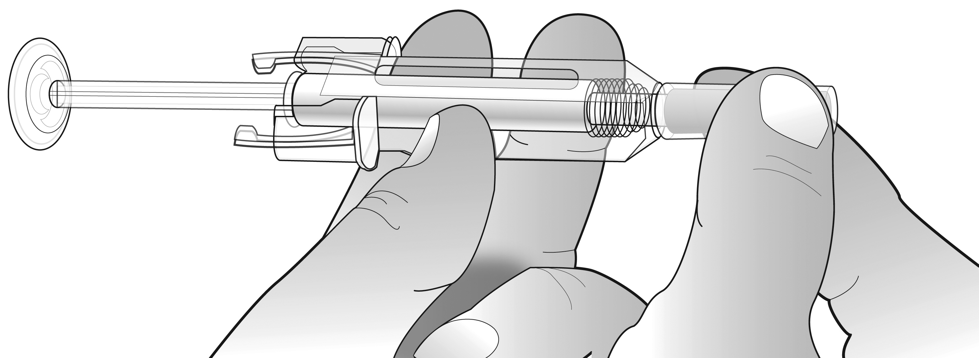  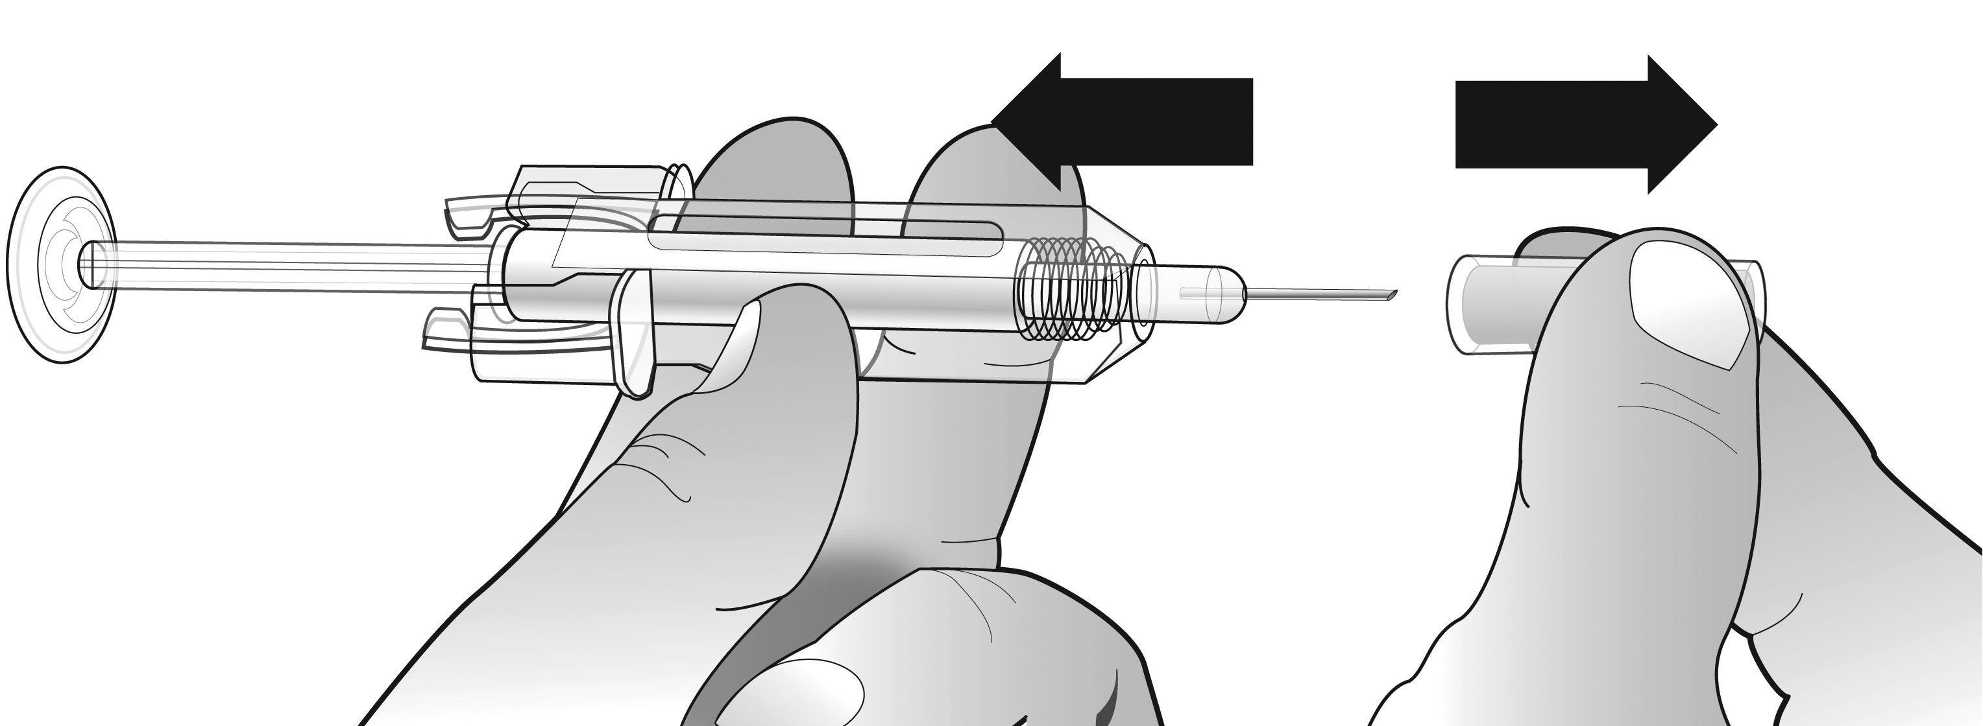  How do I give my injection?  - Disinfect your skin by using an alcohol wipe.  - To avoid bending the needle, gently pull the cover  from the needle straight off without twisting as shown. Do  not touch the needle or push the plunger.  3. You may notice a small air bubble in the pre-filled syringe. You do not have to remove the air bubble before injecting. Injecting the solution with the air bubble is harmless.  4. Pinch (without squeezing) the skin between your thumb and forefinger. Put the needle fully into the skin as shown by your nurse or doctor.  5. Pull slightly on the plunger to check that a blood vessel has not been punctured. If you see blood in the syringe, pull the needle out and re-insert it in another place after disinfecting the skin.  6. Push the plunger with a slow constant pressure, always keeping your skin pinched.  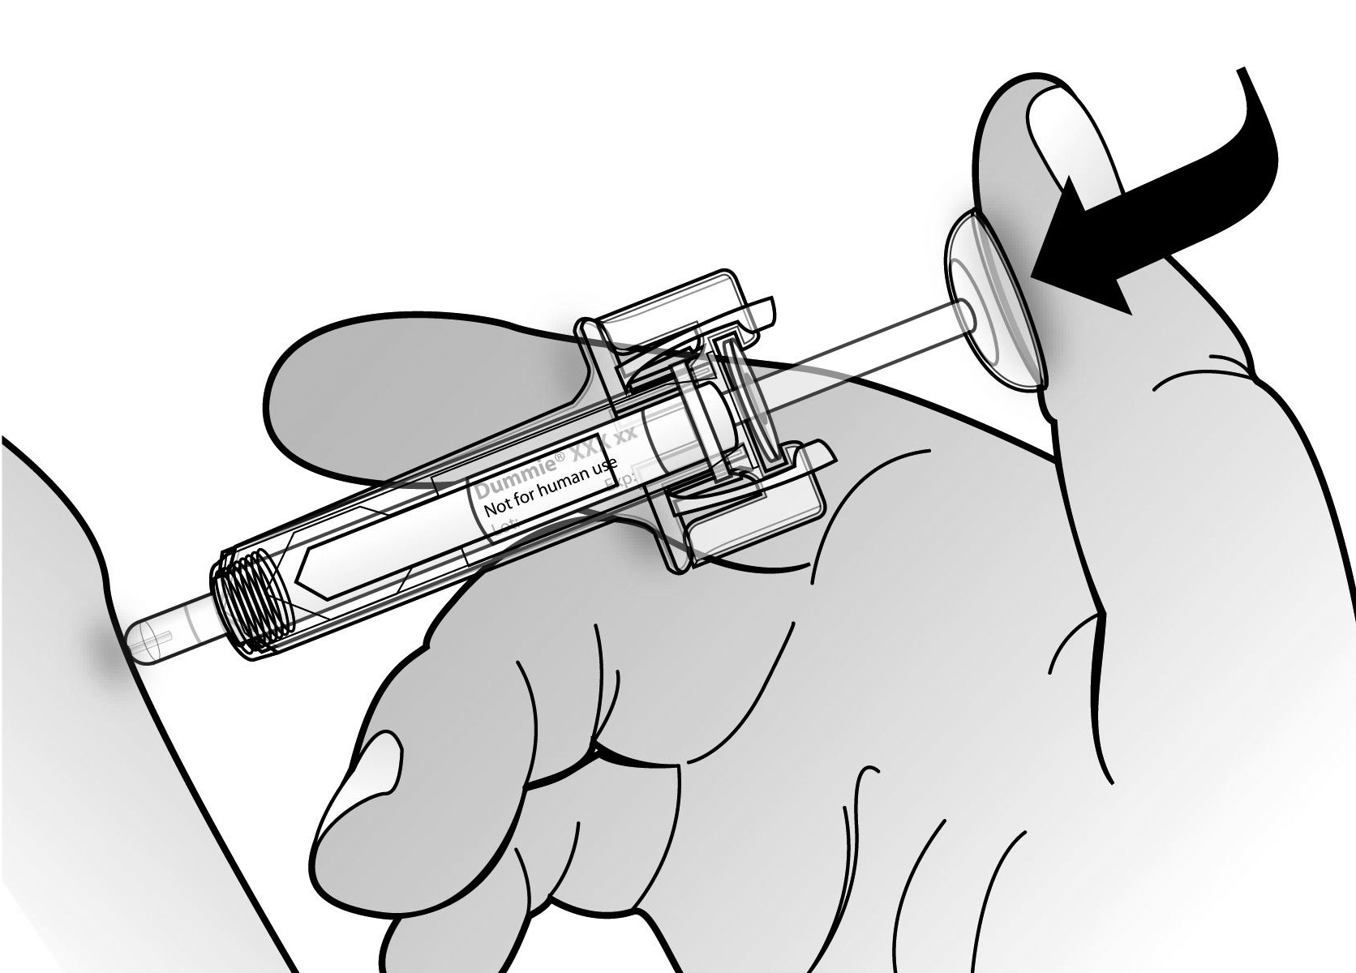  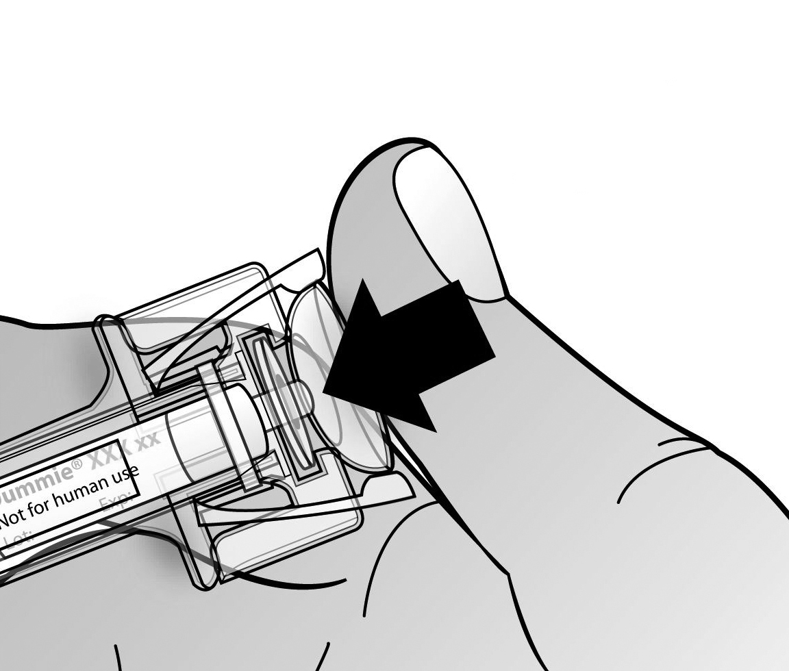  Push the plunger all the way down as far as it will go to inject all the liquid.  The needle guard will not activate unless you empty the pre-filled syringe.  7. While the plunger is still pressed all the way down, remove the needle from the skin, then release the plunger and allow the syringe to move up until the entire needle is covered by the needle guard. If the needle guard is not activated, an incomplete injection may have occurred. Call your health care provider if you think you have not received the full dose.  DO NOT put the needle cover back on the needle.  8. If you notice a spot of blood you may gently dab it away with a cotton ball or tissue. Do not rub the injection site. If needed, you may cover the injection site with a plaster.  9. Only use each pre-filled syringe for one injection. Do not use any Aranesp that is left in the syringe.  2. כדי למנוע כיפוף של המחט, יש למשוך בעדינות את מכסה המחט ישר. מבלי לסובב, כמופיע באיור. אין לגעת במחט או ללחוץ על ידית המזרק  3. עשוייה להיראות בועת אוויר קטנה במזרק המוכן לשימוש. אין צורך לסלק אותה לפני ההזרקה. הזרקת התמיסה עם בועת האוויר איננה גורמת לשום נזק.  3. צבוט/י (בלי ללחוץ) את העור בין האגודל לאצבע. החדר/י את המחט כולה לעור, כפי שהודרכת ע"י האחות או הרופא.  5. יש להזריק את המנה מתחת לעור כפי שהונחית ע"י הרופא, האחות או הרוקח.  משוך/י קלות את ידית המזרק, כדי לוודא שלא נפגע כלי דם. אם מבחינים בדם בתוך המזרק, יש להוציא את המחט מהעור ולהחדיר אותה במקום אחר.  . לחץ/י על ידית המזרק באופן איטי וקבוע. כשהעור עדיין אחוז בין שתי  . לחץ/י על ידית המזרק באופן איטי וקבוע. כשהעור עדיין אחוז בין שתי אצבעותיך.  דחוף/י את הידית עד הסוף, כדי להזריק את כל המנה. מגן המחט לא יופעל, אלא לאחר שהמזרק יתרוקן.  5. כשהידית עודנה לחוצה עד הסוף, הוצא/י את המחט מהעור, שחרר/י את הידית והנח/י למזרק לעלות, עד שכל המחט מכוסה ע"י מגן המחט. אם מגן המחט איננו מופעל, יתכן שלא כל המנה הוזרקה. התקשר לרופא אם לדעתך לא קיבלת את כל המנה.  אין להחזיר את מכסה המחט על המחט.  6. אם הבחנת בכתם דם, יש לנגבו בעדינות עם צמר גפן או נייר טישו. אין לשפשף את מקום ההזרקה. במקרה הצורך, ניתן לכסות את מקום ההזרקה עם אספלנית (פלסטר).  9. יש להשתמש בכל מזרק להזרקה אחת בלבד.  אין להשתמש באראנספ שנותר במזרק.  Remember: If you have any problems, please ask your doctor or nurse for help and advice. | Instructions for Injection with a Pre-filled Syringe with an automatic needle guard  הוראות להזרקה במזרק המוכן מראש עם מגן מחט אוטומטי:  חלק זה של העלון מכיל מידע על אופן ביצוע ההזרקה העצמית של אראנספ. חשוב שלא תנסה/י להזריק לעצמך אם לא הודרכת כיצד לעשות זאת ע"י רופא, אחות או רוקח.  אם יש לך שאלות כלשהן באשר להוראות ההזרקה, עליך לפנות לרופא, לאחות או לרוקח שיסייעו לך.  This part of the leaflet contains information on the way to perform self injections of Aranesp. It is important that you do not try to inject yourself if you haven’t been instructed by your doctor, nurse or pharmacist.  If you have any questions regarding injecting instructions, please refer to your doctor, nurse or pharmacist for assistance.  Pre-filled syringe with clear needle guard  מזרק מוכן מראש עם מגן מחט שקוף  Do Not attempt to unlock the pre-filled syringe prior to injection.  יש להשתמש רק אם מגן המחט נראה כך:  אין להשתמש במקרה ומגן המחט השקוף נראה מופעל (הקפיץ משוחרר).  אל תנסה/י לשחרר את המזרק המוכן לשימוש לפני ההזרקה  אל תגע/י בתפסני מגן המחט.  The pre-filled syringe barrel has a detachable label that can be pulled off after injection. The label is used by healthcare professionals to update a patient’s chart.  לגוף המזרק המוכן לשימוש יש תווית שניתן לתלוש לאחר ההזרקה. התווית מיועדת עבור הצוות הרפואי המעדכן בה את פרטי החולה.  אין להשתמש במזרק המוכן לשימוש אם מכסה המחט האפור הוסר, או אם מגן המחט השקוף הופעל (מכסה את המחט).  Do Not use the pre-filled syringe if the grey needle cap has been removed, or the clear needle guard has been activated (covering the needle).  אין לנסות ולהסיר את התווית הנתלשת שעל גוף המזרק לפני ההזרקה.  How do you or the person injecting you use the Aranesp pre-filled syringe?  Your doctor has prescribed an Aranesp pre-filled syringe for injection into the tissue just under the skin (subcutaneous). Your doctor, nurse, or pharmacist will tell you how much Aranesp you need and how frequently it should be injected.  Equipment:  In order to inject yourself, you will need  - one Aranesp pre-filled syringe; and  - alcohol pad or similar  כיצד להשתמש במזרק המוכן לשימוש (את/ה או מי שמזריק לך)?  הרופא רשם לך אראנספ במזרק מוכן לשימוש להזרקה תחת העור (. (s.c. הרופא, האחות או הרוקח ינחו אותך לאיזו כמות של אראנספ הינך זקוק/ה וכל כמה זמן להזריק אותה.  הציוד הדרוש:  לצורך ההזרקה העצמית דרושים האביזרים הבאים:  - מזרק חדש אחד של אראנספ מוכן לשימוש  - ופד אלכוהול, או דומה  Before giving the injection  מה עליך לעשות לפני מתן ההזרקה העצמית של אראנספ מתחת לעור?  1. Remove the pre-filled syringe from the refrigerator. To remove the pre-filled syringe from the pack, grasp by the middle of the clear needle guard.  - להוציא את המזרק המוכן לשימוש מהמקרר. כדי להוציא את המזרק המוכן מהאריזה. יש לאחוז במרכז מגן המחט השקוף. אין לאחוז במזרק המוכן לשימוש בבוכנה או במכסה המחט, שכן הדבר עלול לפגום בו.  נכון  אל תאחז במזרק המוכן בידית המזרק,במכסה המחט האפור או בתפסני מגן המחט. הדבר עלול להזיק למכשיר או להפעיל את מגן המחט האפור.  Do not pick up the pre-filled syringe by the plunger rod, grey needle cap or needle guard tabs. This could damage the device or activate the clear needle guard.  לא נכון  2. Leave the pre-filled syringe at room temperature for approximately 30 minutes. This will make the injection more comfortable.  2. לשמור אותו בטמפרטורת החדר למשך כ-30 דקות. הדבר יאפשר מהלך הזרקה נוח יותר. אין לחמם את המזרק בכל צורה אחרת שהיא (למשל, במיקרוגל או במים חמים). אין להשאיר את המזרק חשוף ישירות לאור השמש  3. Please note the following directions:  a. Do not warm the pre-filled syringe in hot water or in the microwave.  b. Do not leave the syringe exposed to direct sunlight.  c. Do not pick up the pre-filled syringe by the plunger rod, grey needle cap, or needle guard tabs.  d. Do not shake the pre-filled syringe.  e. Do not remove the grey needle cap from the pre-filled syringe until you are ready to inject.  f. Do not attempt to activate the pre-filled syringe prior to injection.  g. Do not attempt to remove the clear needle guard from the pre-filled syringe.  h. Do not try to remove the detachable label on the pre-filled syringe barrel before administering the injection.  Keep pre-filled syringes out of the sight and reach of children.  3. יש לשים לב להוראות הבאות:  א. אין לחמם את המזרק המוכן במים חמים או במיקרוגל.  ב. אין להשאיר את המזרק חשוף לאור שמש ישיר.  ג. אין לאחוז במזרק המוכן בידית המזרק, במכסה המחט האפור, או בתפסני מגן המחט.  ד. אין לנער את המזרק המוכן לשימוש.  ה. אין להסיר את מכסה המחט האפור מהמזרק המוכן, אלא כשמוכנים להזרקה.  ו. אל תנסה/י להפעיל את המזרק המוכן לפני ההזרקה.  ז. אל תנסה/י להסיר את מגן המחט השקוף מהמזרק המוכן.  ח. אל תנסה/י להסיר את התווית הנתלשת שעל גוף המזרק המוכן לפני ביצוע ההזרקה.  יש לשמור את המזרקים המוכנים לשימוש מחוץ להישג ידם וראייתם של ילדים.  4. Check the following before continuing:  a. You have the correct product and dose prescribed by your doctor.  b. Expiry date on the pre-filled syringe label (EXP). Do not use it if the date has passed the last day of the month shown.  c. The appearance of Aranesp. It must be a clear, colourless or slightly pearly liquid. If it is cloudy or there are particles in it, you must not use it.  d. You may notice a small air bubble in the pre-filled syringe. You do not have to remove the air bubble before injecting. Injecting the solution with the air bubble is harmless.  - יש לבדוק את הדברים הבאים לפני שממשיכים:  - בידך המוצר הנכון והמנה שנרשמה ע"י הרופא.  - מועד התפוגה על תווית המזרק המוכן (EXP). אין להשתמש אם עבר היום האחרון של החודש המצוין.  - מראה האראנספ. עליו להיות נוזל שקוף, חסר צבע או מעט בגוון פנינה. אם הוא עכור או יש בתוכו חלקיקים, אין להשתמש בו.  - עלולה להיראות בנוזל של המזרק המוכן בועת אוויר קטנה. אין צורך לסלק אותה לפני ההזרקה. הזרקת התמיסה עם בועת האוויר איננה מזיקה.  .  אין להסיר את המכסה מהמזרק המוכן, אלא כשמוכנים להזרקה  5יש לוודא שבמזרק יש את המנה הנכונה שהרופא רשם לך.  6יש לבדוק את תאריך התפוגה הרשום על המזרק המוכן לשימוש (EXP). אין להשתמש במזרק אם כבר עבר היום האחרון של החודש הנזכר.  7יש לבדוק את מראה תכולת המזרק. הנוזל חייב להיות צלול, ללא צבע או נוטה מעט לצבע פנינה. אם הנוזל עכור או יש בו חלקיקים, אין להשתמש בו.  5. Wash your hands thoroughly.  6. Put all of the equipment you need within reach on a comfortable, well-lit and clean surface.  6.יש להניח את כל הציוד שדרוש בהישג יד. על יש לאתר משטח נוח, מואר היטב ונקי ולהניח עליו את כל הציוד הנדרש בהישג יד.  Where should I give my injection?  6. Push the plunger with a slow constant pressure, always keeping your skin pinched.  7. While the plunger is still pressed all the way down, remove the needle from the skin, then release the plunger and allow the syringe to move up until the entire needle is covered by the needle guard. If the needle guard is not activated, an incomplete injection may have occurred. Call your health care provider if you think you have not received the full dose.  2. כדי למנוע כיפוף של המחט, יש למשוך בעדינות את מכסה המחט האפור ישר. מבלי לסובב, כמופיע באיור. אין לגעת במחט או ללחוץ על ידית המזרק  3. עשוייה להיראות בועת אוויר קטנה במזרק המוכן לשימוש. אין צורך לסלק אותה לפני ההזרקה. הזרקת התמיסה עם בועת האוויר איננה גורמת לשום נזק.  3. צבוט/י (בלי ללחוץ) את העור בין האגודל לאצבע. החדר/י את המחט כולה לעור, כפי שהודרכת ע"י האחות או הרופא,.  5. יש להזריק את המנה מתחת לעור כפי שהונחית ע"י הרופא, האחות או הרוקח.  משוך/י קלות את ידית המזרק, כדי לוודא שלא נפגע כלי דם. אם מבחינים בדם בתוך המזרק, יש להוציא את המחט מהעור ולהחדיר אותה במקום אחר.  . לחץ/י על ידית המזרק באופן איטי וקבוע. כשהעור עדיין אחוז בין שתי  אצבעותיך.  דחוף/י את הידית עד הסוף, כדי להזריק את כל המנה. מגן המחט השקוף לא יופעל, אלא לאחר שהמזרק יתרוקן.  5. כשהידית עודנה לחוצה עד הסוף, הוצא/י את המחט מהעור, שחרר/י את הידית והנח/י למזרק לעלות, עד שכל המחט מכוסה ע"י מגן המחט השקוף. אם מגן המחט השקוף איננו מופעל, יתכן שלא כל המנה הוזרקה. התקשר לרופא אם לדעתך לא קיבלת את כל המנה.  אין להחזיר את מכסה המחט האפור על המחט.  6. אם הבחנת בכתם דם, יש לנגבו בעדינות עם צמר גפן או נייר טישו. אין לשפשף את מקום ההזרקה. במקרה הצורך, ניתן לכסות את מקום ההזרקה עם אספלנית (פלסטר).  9. יש להשתמש בכל מזרק להזרקה אחת בלבד.  אין להשתמש באראנספ שנותר במזרק.  How do I give my injection?  1. Clean your skin by using an alcohol wipe.  Do not put the grey needle cover back on the needle.  6. If you notice a spot of blood you may gently dab with a cotton ball or tissue. Do not rub the injection site. If needed, you may cover the injection site with a plaster.  Do not use any Aranesp that is left in the syringe.  Remember: Only use each pre-filled syringe for one injection. If you have any problems, please ask your doctor or nurse for help and advice.  אין להשתמש באראנספ שנותר במזרק.  זכור: יש להשתמש בכל מזרק מוכן להזרקה אחת. אם מתעוררת בעיה כלשהי, אל תהסס/י לבקש סיוע ועיצה מהרופא או מהאחות.
  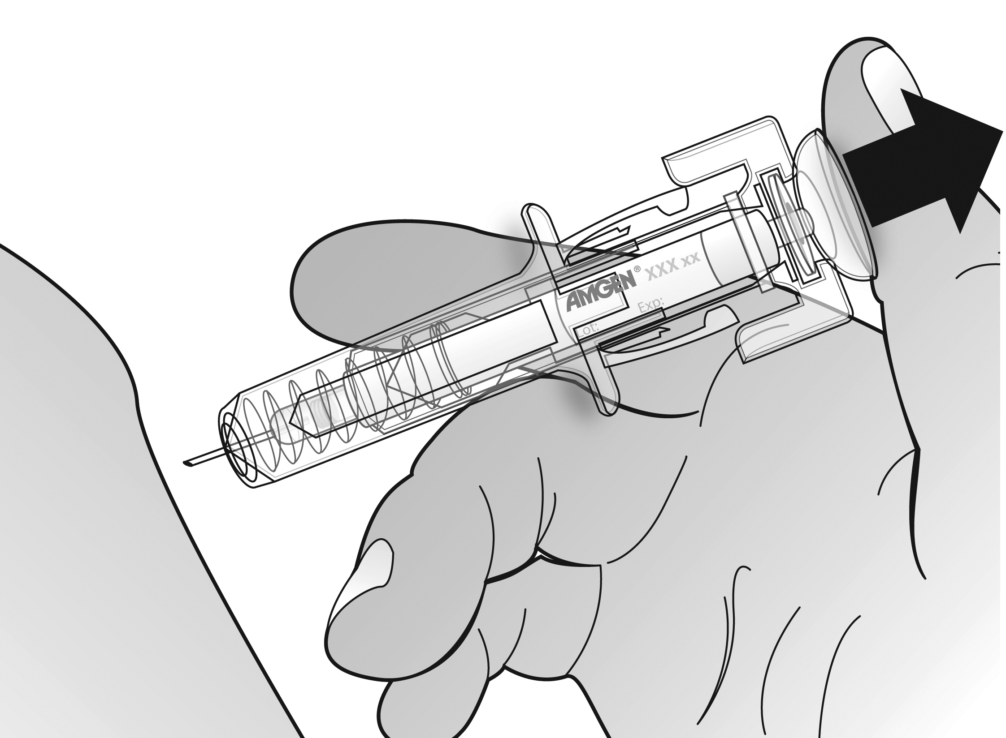 | 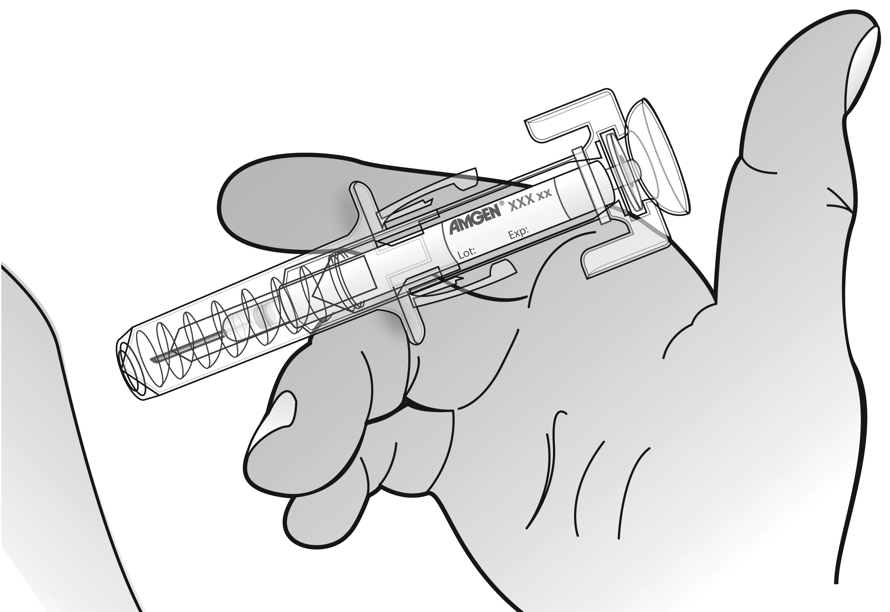
   | Needle guard tabs |  | Clear needle guard
  Plunger | 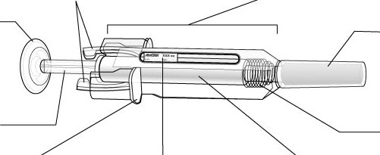 |  |  |  | Grey needle cap
  Plunger rod |  |  |  |  | Needle guard spring
   | Finger grips | Flag label and window |  | Pre-filled syringe
  Use if the clear needle guard appears as shown below:
  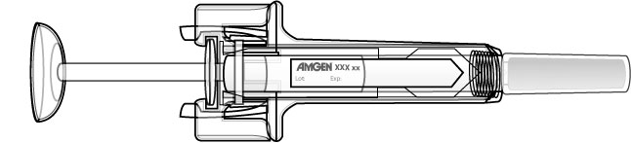
  Do not use if the clear needle guard appears to be activated (spring is extended).
  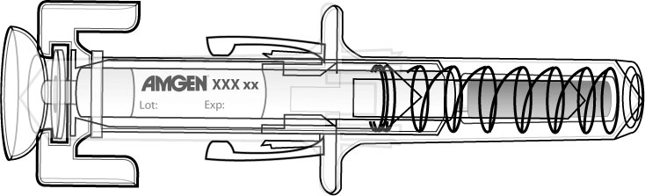
  Do not touch the needle guard tabs.
  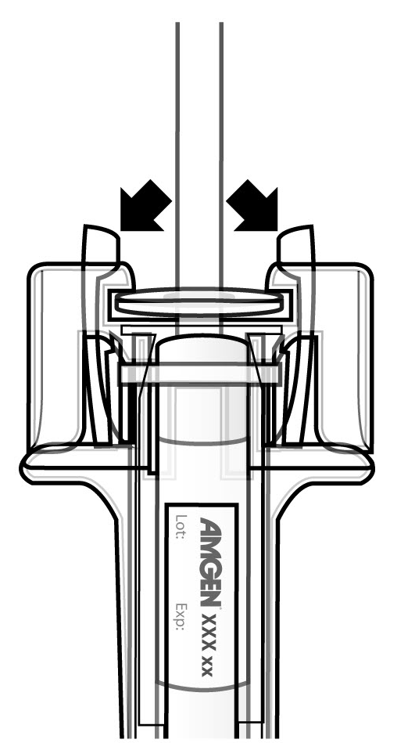
   | תפסני מגן המחט |  |  | מגן המחט השקוף
  ראש ידית המזרק |  |  |  |  |  | מכסה מחט אפור
  ידית המזרק |  |  |  |  |  | קפיץ מגן המחט
   | מאחז לאצבעות | חלונית התווית |  |  | מזרק מוכן לשימוש
  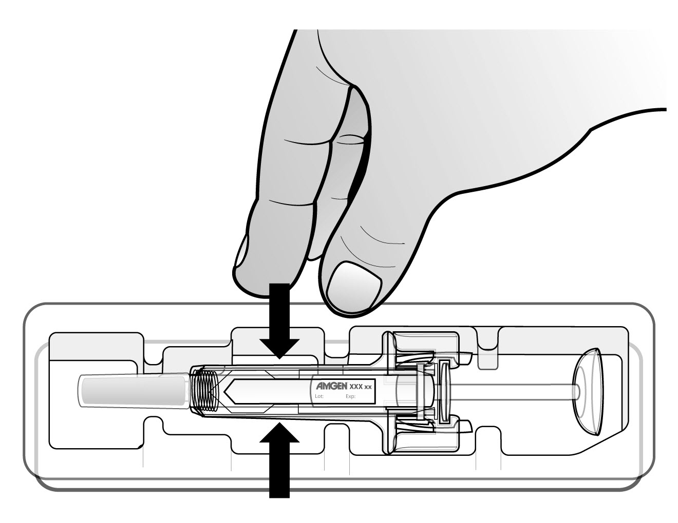
  Correct
  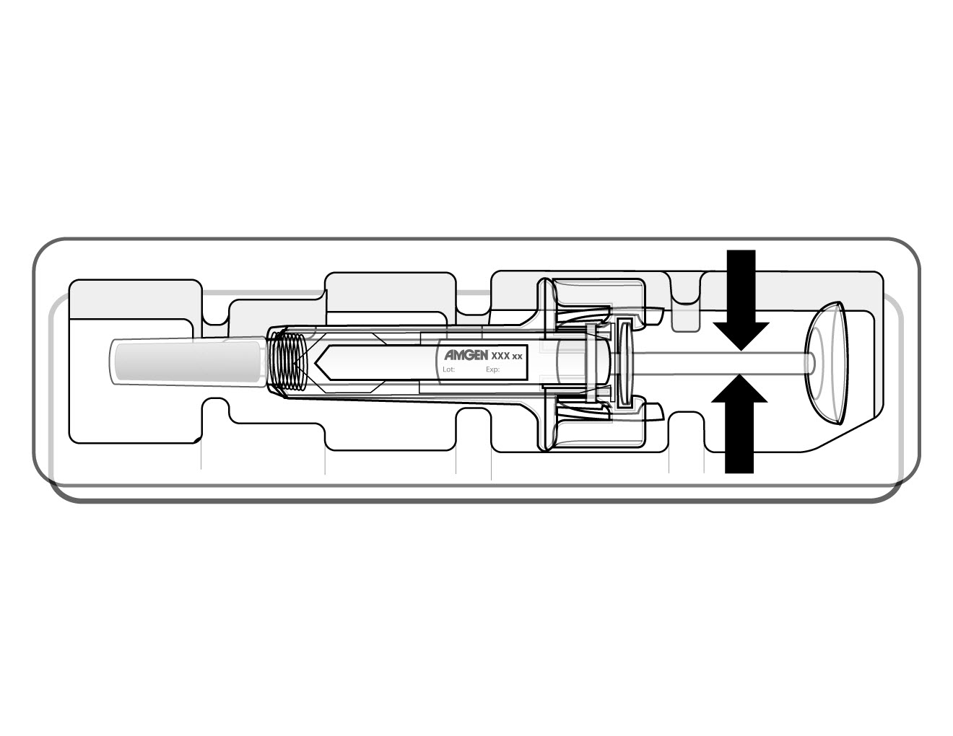
  Incorrect
  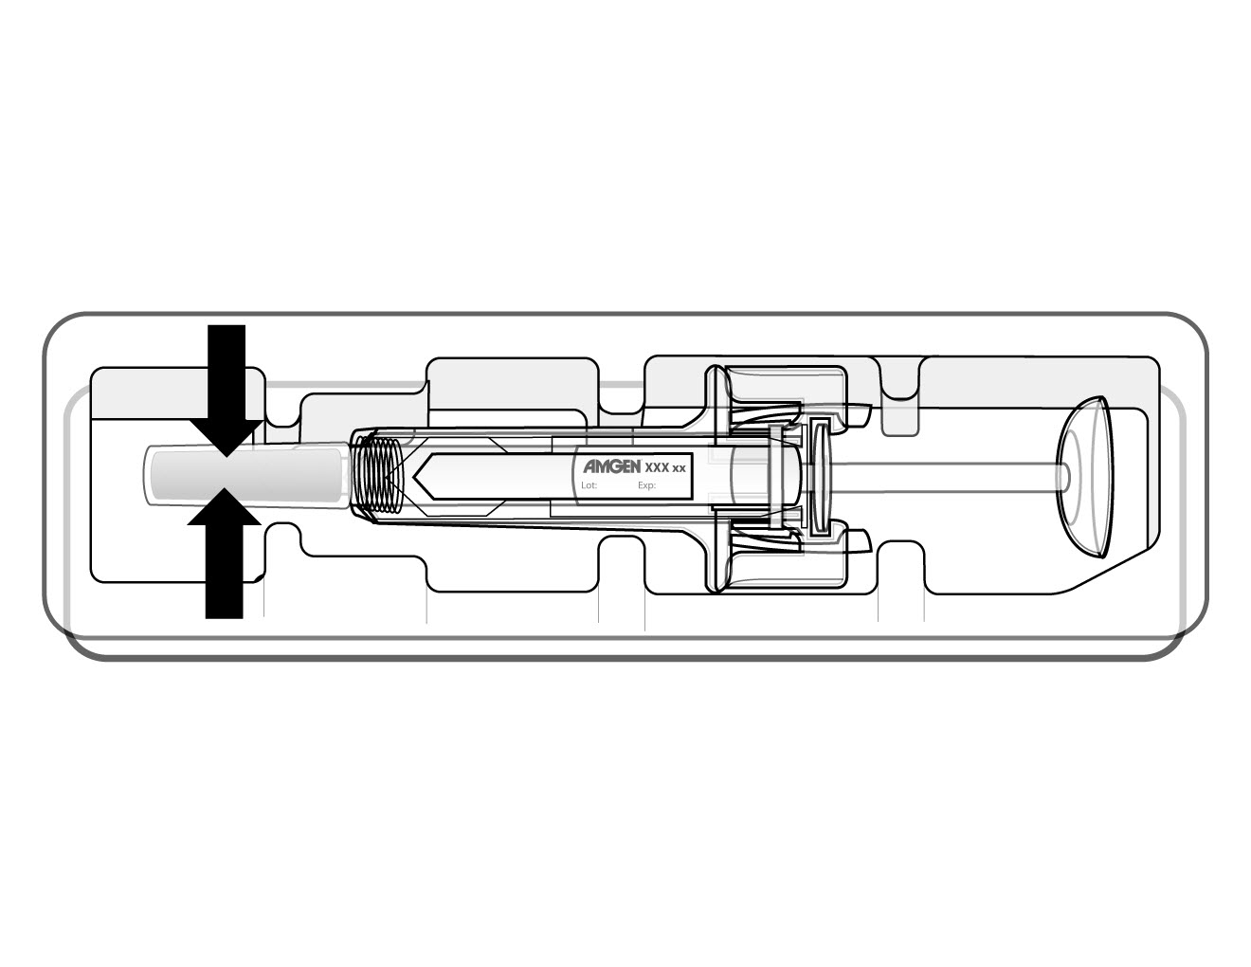
  Incorrect
  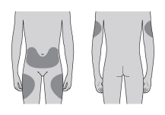 | The best places to inject yourself are the top of your thighs and the abdomen. If someone else is injecting for you, they can also use the back of your arms.
  You may
  ניתן לשנות את מקום ההזרקה, אם הבחנת שהאזור אדום או כואב.
  2. To avoid bending the needle, carefully pull the grey needle cap from the needle straight off. Do not touch the needle or push the plunger. | 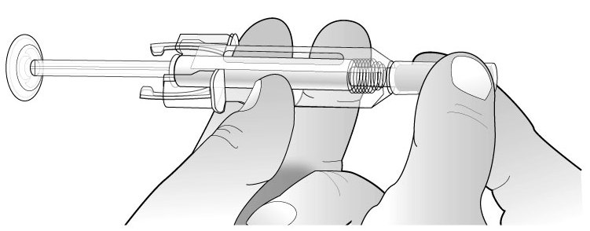
   | 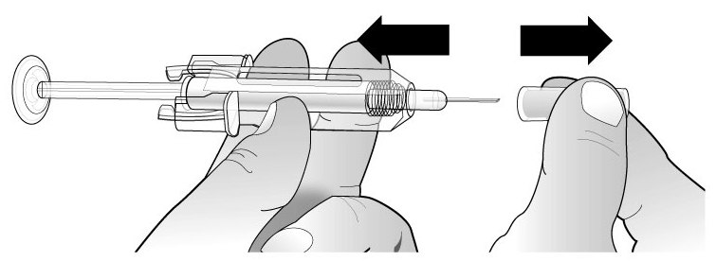
  3. Pinch (without squeezing) the skin using your thumb and forefinger. Insert the needle into the skin. | 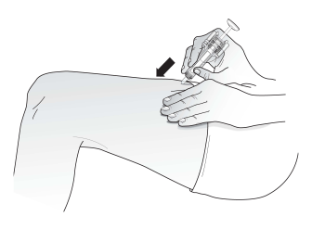
  4. Push the plunger down with a slow constant pressure. | 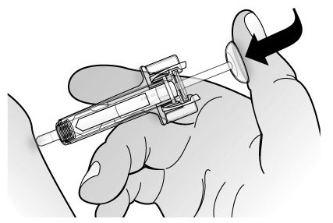
  Push the plunger all the way down as far as it will go to inject all the liquid. The clear needle guard will not activate unless you empty the pre-filled syringe. | 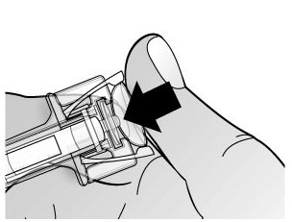
  5. While the plunger is still pressed all the way down, remove the needle from the skin, then release the plunger and allow the syringe to move up until the entire needle is covered by the clear needle guard. If the clear needle guard is not activated, an incomplete injection may have occurred. Call your health care provider if you think you have not received the full dose. | 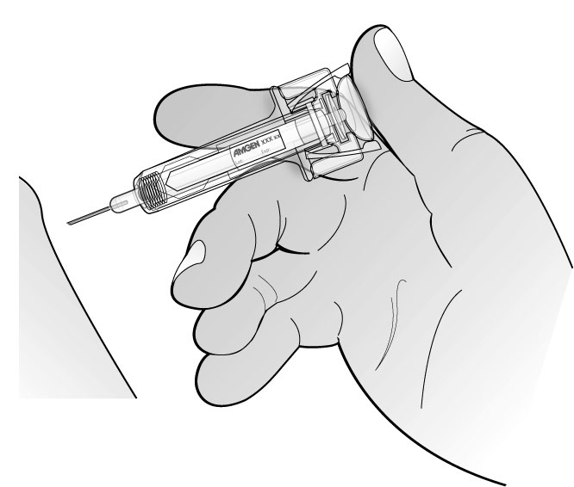
   | 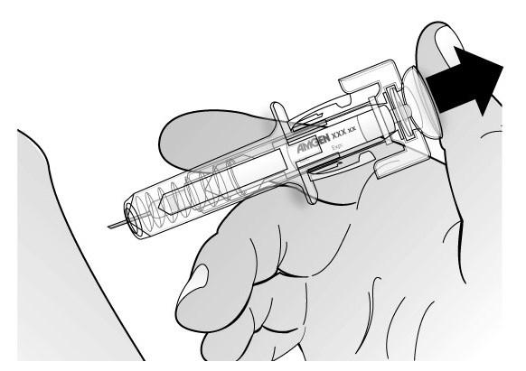
   | 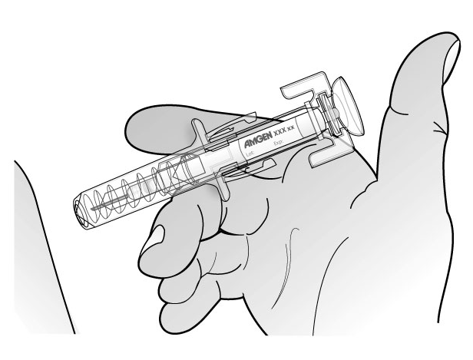
The following information is intended for medical or healthcare professionals only: | How to remove the detachable label  The Aranesp pre-filled syringe comes with a detachable label that can be removed and placed on a patient’s chart.  NOTE: Only perform this step after you have given the injection and the safety guard is covering the needle.  1. Hold the syringe as shown and rotate the plunger towards you until you can see the tab of the label within the opening of the window as shown below.  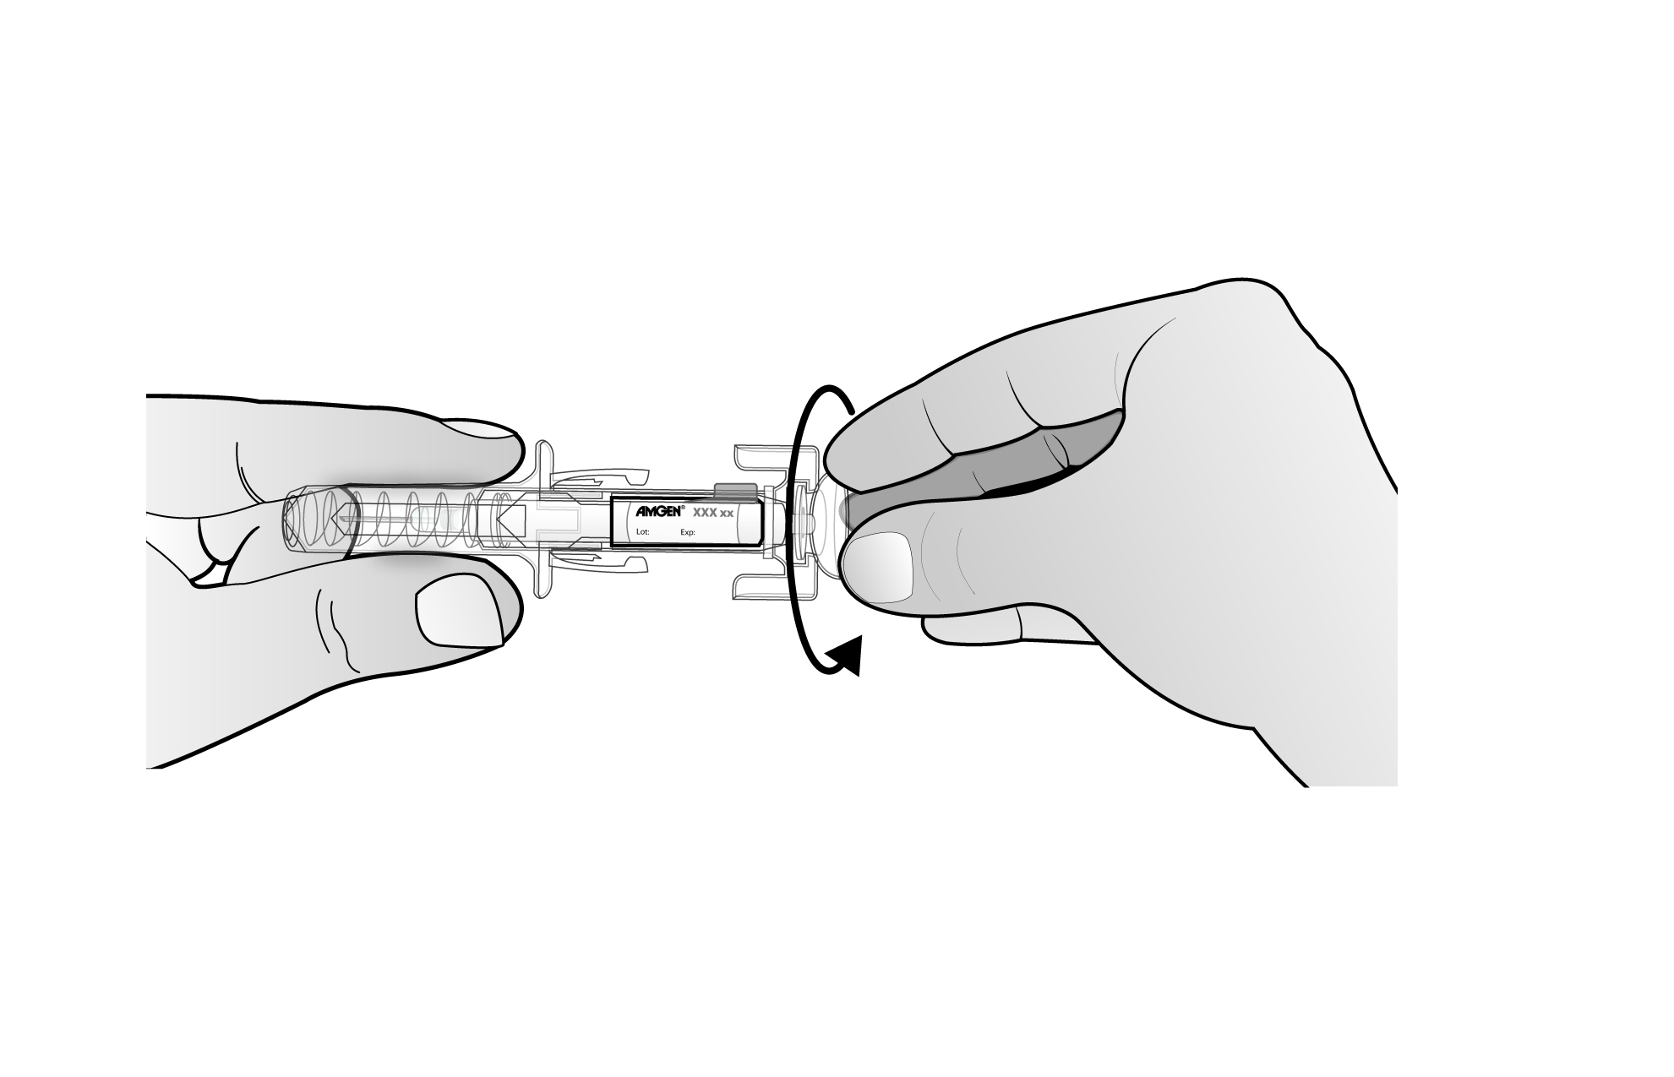  2. Slightly rotate the plunger away from you until the tab sticks up through the window as shown below.  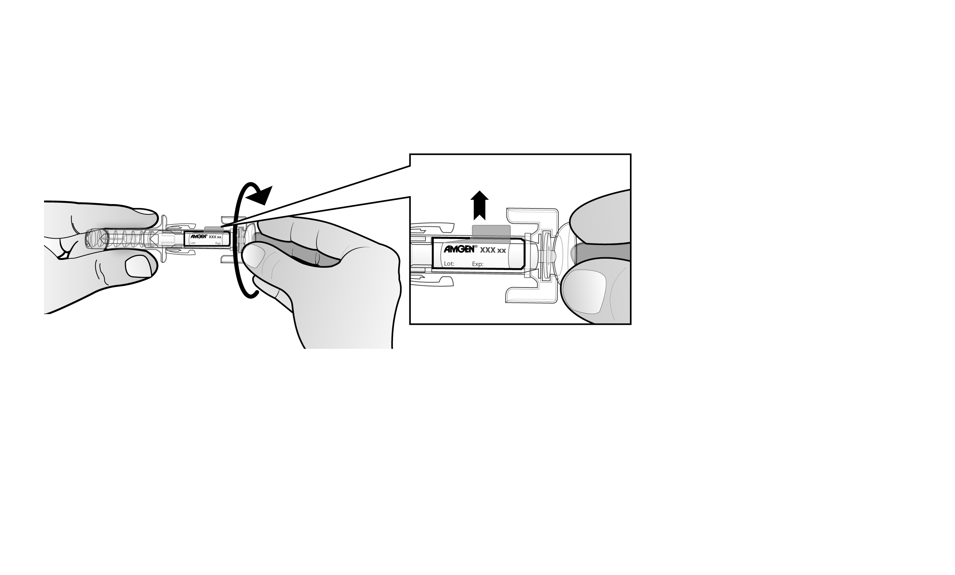  3. Pull the tab up through the window, and then tear across the perforation, as shown below.  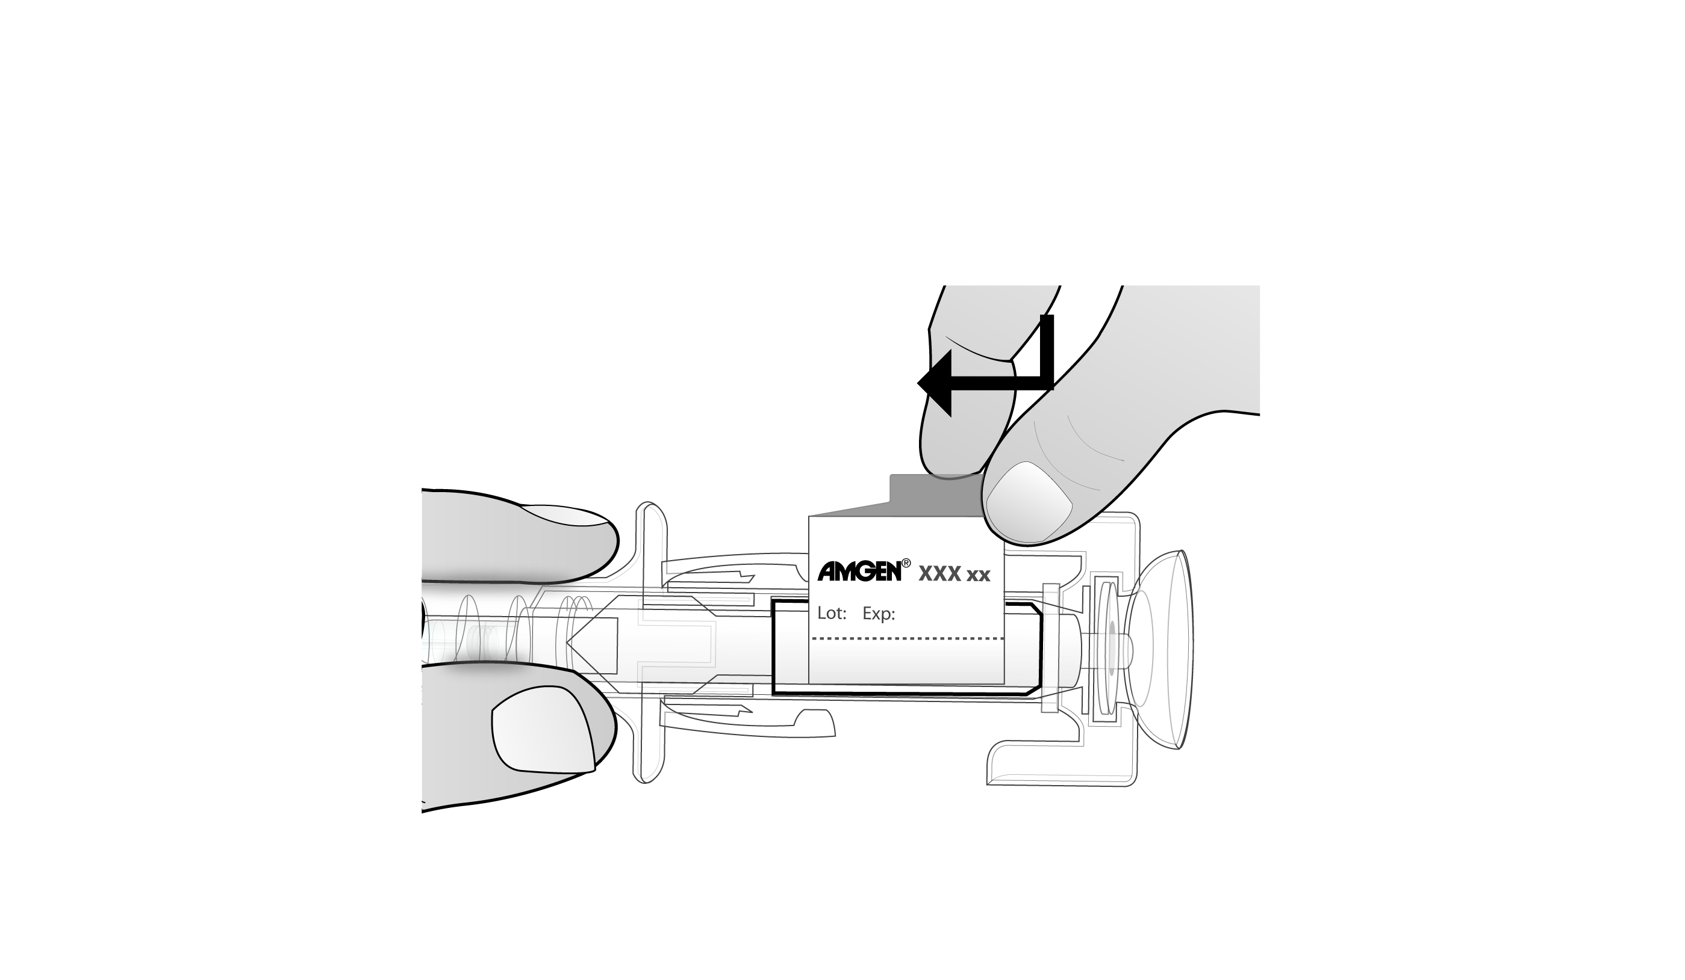  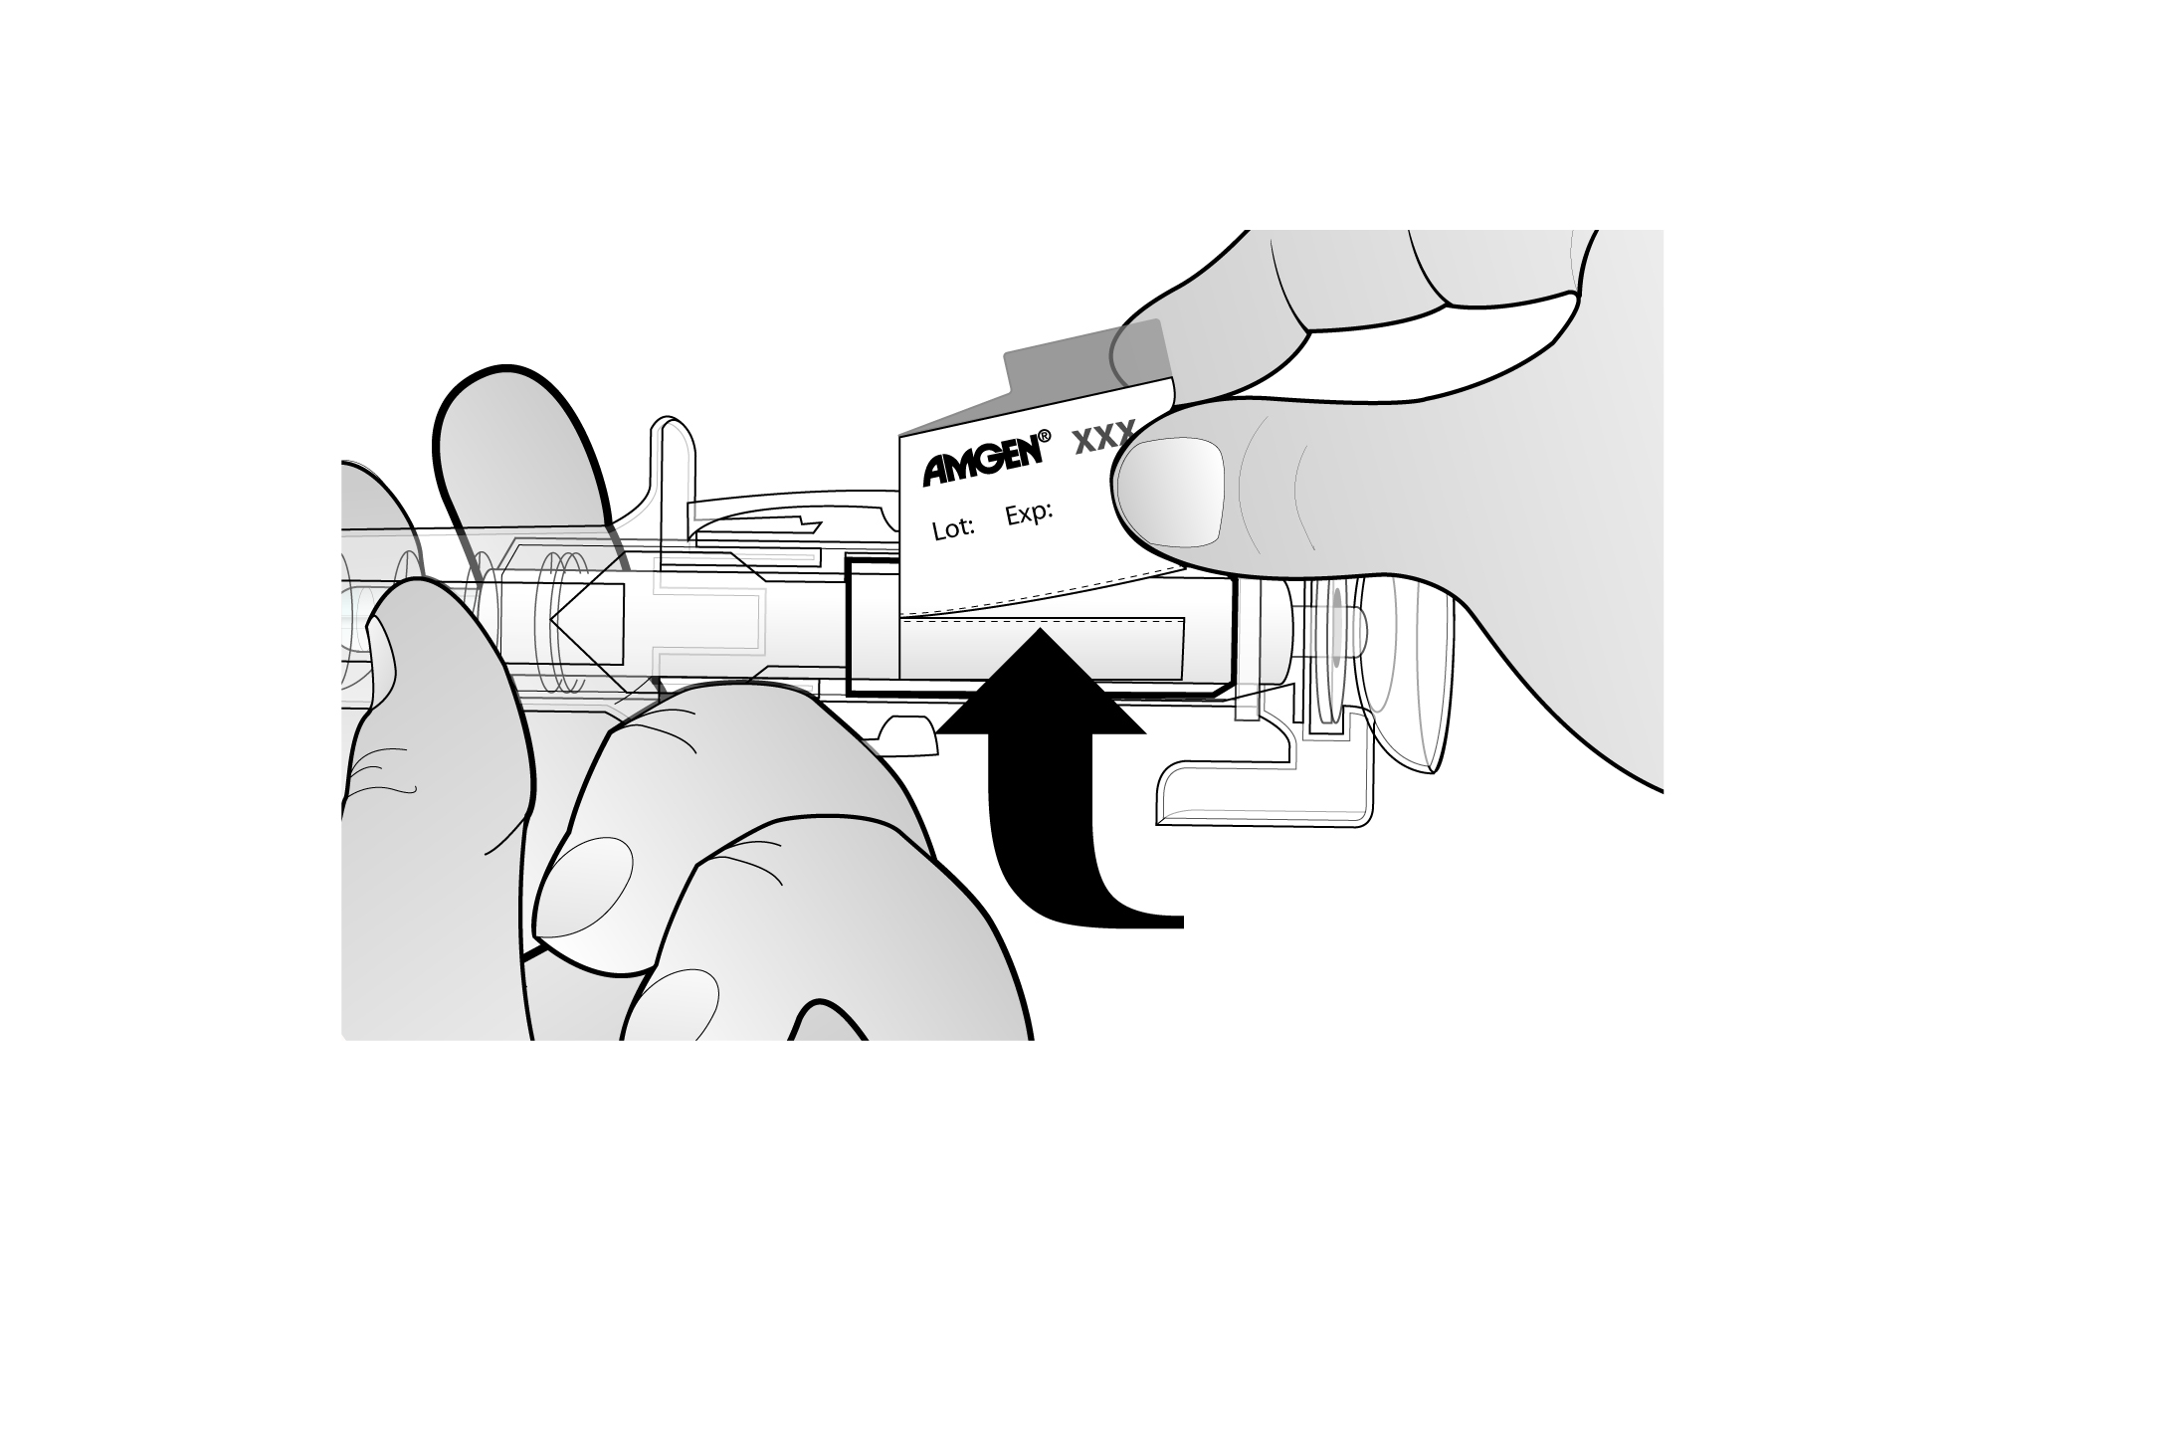  Tear at perforation | How to remove the detachable label  The Aranesp pre-filled syringe comes with a detachable label that can be removed and placed on a patient’s chart.  Note: Only perform this step after you have given the injection and the clear needle guard is covering the needle.
  1. Hold the syringe as shown and rotate the plunger towards you until you can see the tab of the label within the opening of the window as shown. | 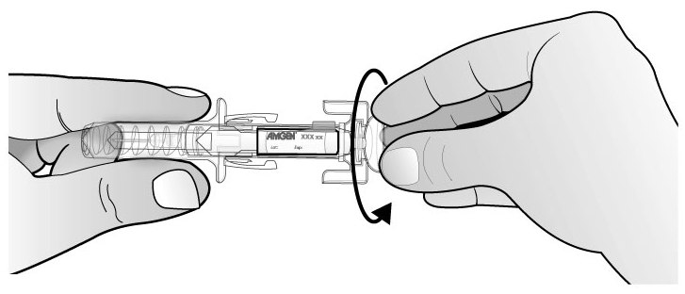
  2. Slightly rotate the plunger away from you until the tab sticks up through the window as shown. | 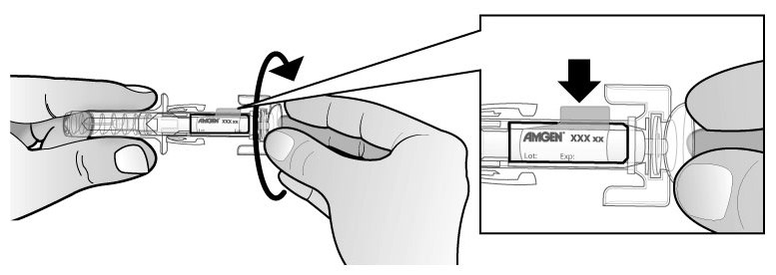
  3. Pull the tab up through the window, and then tear across the perforation, as shown. | 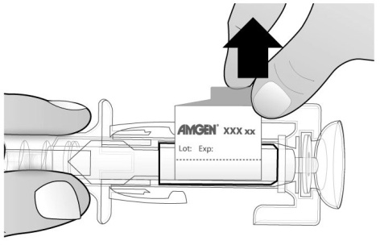
   |  | Pull
   | 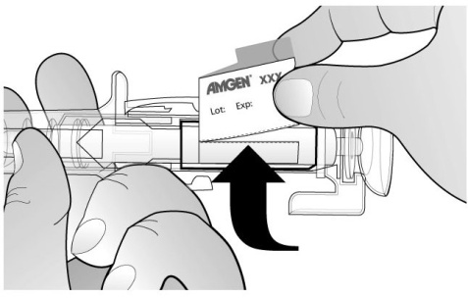
   |  | Tear at perforation

The leaflet, in which the changes requested are yellow highlighted, was sent by e-mail on…………………
X
העלון, שבו מסומנים השינויים המבוקשים על רקע צהוב הועבר בדואר אלקטרוני בתאריך.................

A patient leaflet exists and it's adequately updated.
X
קיים עלון לצרכן והוא מעודכן בהתאם.

Reference for the request:
X
אסמכתא לבקשה: עדכוני בטיחות שאושרו באירופה Safety updates v92 & v97

The above change was approved by the health authorities in:
X
השינוי הנ"ל אושר על ידי רשויות הבריאות ב:European Union

I, the appointed pharmacist of the company ……., hereby declare that there are no additional changes in the leaflet.
אני, הרוקח הממונה של חברת Amgen Europe B.V. מצהיר בזה כי אין שינויים נוספים בעלון.
_______Sigal Bendor__________
^{חתימת הרוקח הממונה}

Announcement regarding harshment (safety information) in the Patient Leaflet (PIL)

הודעה על החמרה ( מידע בטיחות) בעלון לצרכן

תאריך05/03/2012
Name of the product:
שם תכשיר באנגלית:
ARANESP® 10, 20, 30, 40, 50, 60, 80, 100, 150, 300, 500 µg
Solution for Injection PFS

Registration No's:
מספר רישום:
Aranesp 10 | 1243830392 00
Aranesp 20 | 1244030394 00
Aranesp 30 | 1244130395 00
Aranesp 40 | 1244230396 00
Aranesp 50 | 1244330397 00
Aranesp 60 | 1244430398 00
Aranesp 80 | 1244530399 00
Aranesp 100 | 1244630400 00
Aranesp 150 | 1244730401 00
Aranesp 300 | 1296530888 00
Aranesp 500 | 1333231237 00

Name of the registration owner:
Amgen Europe B.V. שם בעל הרישום_

Details regarding the requested changes
פרטים על השינוי/ים המבוקש/ים
Chapter in leaflet  פרק בעלון | Current text  טקסט נוכחי | New text  טקסט חדש
Warnings | If you have symptoms which include severe headache, drowsiness, confusion, problems with your eyesight, nausea, vomiting or fits (seizures), it could mean that you have very high blood pressure. This has been reported in patients with chronic renal failure treated with Aranesp. If you experience these symptoms you should contact your doctor.  - אם יש לך תסמינים הכוללים כאבי ראש חמורים, נמנום, בלבול, בעיות עם הראייה שלך, בחילה או הקאות (התקפים), יכול להיות שיש לך לחץ דם גבוה מאוד. תופעה זו דווחה בחולים עם אי ספיקת כליות כרונית שטופלו בארנספ | - If you have symptoms which include severe headache, drowsiness, confusion, problems with your eyesight, nausea, vomiting or fits (seizures), it could mean that you have very high blood pressure. If you experience these symptoms you should contact your doctor.  אם יש לך תסמינים הכוללים כאבי ראש חמורים, נמנום, בלבול, בעיות עם הראייה שלך, בחילה או הקאות (התקפים), יכול להיות שיש לך לחץ דם גבוה מאוד. תופעה זו דווחה בחולים עם אי ספיקת כליות כרונית שטופלו בארנספ.
Side effects | Treatment with Aranesp, as with any other medicine, may cause side effects, though not everyone gets them.  The following side effects have been experienced by some patients in clinical trials taking Aranesp:  Chronic renal failure patients  Very Common (seen in more than 10 in 100 people):  - High blood pressure (hypertension)  Common (seen in more than 1 in 100 people):  - Pain around the injection site  - Rash and/or redness of the skin  Uncommon (seen in more than 1 in 1000 people):  - Blood clots (thrombosis)  Cancer patients  Very common (seen in more than 10 in 100 people)  - Fluid retention (oedema)  Common (seen in more than 1 in 100 people)  - Blood clots (thrombosis)  - Pain around the area injected  - Rash and/or redness of the skin  The following side effects have been experienced by some patients after Aranesp has been marketed:  Very rare (seen in less than 1 in 10,000 people)  - Pure red cell aplasia (PRCA) – (anaemia, unusual tiredness, lack of energy)  Frequency unknown  - Serious allergic reactions which may include:  - Sudden life-threatening allergic reactions (anaphylaxis)  - Swelling of the face, lips, mouth, tongue or throat which may cause difficulty in swallowing orbreathing (angioedema)  - Shortness of breath (allergic bronchospasm)  - Skin rash  - Hives (urticaria)  - Convulsions (fits and seizures) have been reported in patients treated with Aranesp.  - Hypertension  Inform your doctor, nurse or pharmacist if you have any of these symptoms or if you notice any side effects, even those that are not mentioned in this leaflet.  תופעות הלוואי הבאות הופיעו אצל חלק מהחולים בזמן הניסויים הקליניים בעת נטילת אראנספ:  חולים עם כשל כלייתי כרוני  תופעות נפוצות מאד (מופיעות אצל יותר מ-10 מתוך 100 אנשים):  - לחץ דם גבוה  תופעות נפוצות (מופיעות אצל יותר מ-1 מתוך 100 אנשים):  - כאב מסביב למקום ההזרקה  - פריחה ו/או אדמומיות של העור  תופעות לא נפוצות (מופיעות אצל יותר מ-1 מתוך 1,000 איש):  - קרישי דם (טרומבוזה)  חולי סרטן  תופעות נפוצות מאד (מופיעות אצל יותר מ-10 מתוך 100 אנשים):  - אצירת נוזלים (בצקת)  תופעות נפוצות (מופיעות אצל יותר מ-1 מתוך 100 אנשים):  - קרישי דם (טרומבוזה)  - כאב מסביב למקום ההזרקה  - פריחה ו/או אדמומיות של העור  תופעות הלוואי הבאות הופיעו אצל חלק מהחולים אחרי התחלת השיווק של אראנספ:  תופעות נדירות מאד (מופיעות אצל פחות מ-1 מתוך 10,000 איש):  - אפלסיה של הכדוריות האדומות (PRCA) - (אנמיה, עייפות בלתי רגילה, חוסר אנרגיה)  תדירות בלתי ידועה  - תגובות אלרגיות חמורות שעשויות לכלול:  - תגובות אלרגיות פתאומיות ומסכנות חיים (שוק אנאפילקטי,רגישות יתר לחלבונים)  - התנפחות של הפנים, השפתיים, הלשון או הגרון, העלולה לגרום לקושי בבליעה או בנשימה  - קוצר נשימה (עווית אלרגית של הסימפונות)  - פריחה בעור  - חרלת/ גרדת (אורטיקריה).  - עוויתות דווחו אצל חולים שטופלו באראנספ.  - לחץ דם גבוה  עליך לדווח לרופא, לאחות או לרוקח אם הופיעה אצלך אחת מתופעות הלוואי הנזכרות, או אם הבחנת בתופעות לוואי, גם כאלה שאינן נזכרות כאן. | Treatment with Aranesp, as with any other medicine, may cause side effects, though not everyone gets them.  The following side effects have been experienced by some patients taking Aranesp:  Chronic renal failure patients  Very Common (seen in more than 10 in 100 people):  - High blood pressure (hypertension)  - Allergic reactions  Common (seen in more than 1 in 100 people):  - Stroke  - Pain around the injection site  - Rash and/or redness of the skin  Uncommon (seen in more than 1 in 1000 people):  - Blood clots (thrombosis)  - Convulsions (fits and seizures)  Frequency unknown  - Pure red cell aplasia (PRCA) – (anaemia, unusual tiredness, lack of energy)  Cancer patients  Very common (seen in more than 10 in 100 people)  - Allergic reactions  - Fluid retention (oedema)  Common (seen in more than 1 in 100 people)  - High blood pressure (hypertension)  - Blood clots (thrombosis)  - Pain around the area injected  - Rash and/or redness of the skin  Uncommon (seen in more than 1 in 1,000 people)  - Convulsions (fits and seizures)  All patients  Frequency unknown  - Serious allergic reactions which may include:  - Sudden life-threatening allergic reactions (anaphylaxis)  - Swelling of the face, lips, mouth, tongue or throat which may cause difficulty in swallowing orbreathing (angioedema)  - Shortness of breath (allergic bronchospasm)  - Skin rash  - Hives (urticaria)  If any of the side effects gets serious, or if you notice any side effects not listed in this leaflet, please tell your doctor or pharmacist.  תופעות הלוואי הבאות הופיעו אצל חלק מהחולים בזמן הניסויים הקליניים בעת נטילת אראנספ:  חולים עם כשל כלייתי כרוני  תופעות נפוצות מאד (מופיעות אצל יותר מ-10 מתוך 100 אנשים):  - לחץ דם גבוה  - תגובות אלרגיות  תופעות נפוצות (מופיעות אצל יותר מ-1 מתוך 100 אנשים):  - ארוע מוחי  - כאב מסביב למקום ההזרקה  - פריחה ו/או אדמומיות של העור  תופעות לא נפוצות (מופיעות אצל יותר מ-1 מתוך 1,000 איש):  - קרישי דם (טרומבוזה)  - עוויתות  תדירות לא ידועה  - אפלסיה של הכדוריות האדומות (PRCA) (אנמיה, עייפות בלתי רגילה, חוסר אנרגיה)  חולי סרטן  תופעות נפוצות מאד (מופיעות אצל יותר מ-10 מתוך 100 אנשים):  - תגובות אלרגיות  - אצירת נוזלים (בצקת)  תופעות נפוצות (מופיעות אצל יותר מ-1 מתוך 100 אנשים):  - לחץ דם גבוה  - קרישי דם (טרומבוזה)  - כאב מסביב למקום ההזרקה  - פריחה ו/או אדמומיות של העור  תופעות לא נפוצות (מופיעות אצל יותר מ-1 מתוך 1,000 איש):  - עוויתות  תופעות הלוואי הבאות הופיעו אצל חלק מהחולים אחרי התחלת השיווק של אראנספ:  תופעות נדירות מאד (מופיעות אצל פחות מ-1 מתוך 10,000 איש):  - אפלסיה של הכדוריות האדומות (PRCA) - (אנמיה, עייפות בלתי רגילה, חוסר אנרגיה)  אצל כל החולים  תדירות בלתי ידועה  - תגובות אלרגיות חמורות שעשויות לכלול:  - תגובות אלרגיות פתאומיות ומסכנות חיים (שוק אנאפילקטי,רגישות יתר לחלבונים)  - התנפחות של הפנים, השפתיים, הלשון או הגרון, העלולה לגרום לקושי בבליעה או בנשימה  - קוצר נשימה (עווית אלרגית של הסימפונות)  - פריחה בעור  - חרלת/ גרדת (אורטיקריה).  - עוויתות דווחו אצל חולים שטופלו באראנספ.  - לחץ דם גבוה  אם איזו שהיא מתופעות הלוואי הופכת לחמורה, או אם הבחנת בתופעות לוואי שאינן נזכרות בעלון זה, עליך לדווח לרופא או לרוקח.  עליך לדווח לרופא, לאחות או לרוקח אם הופיעה אצלך אחת מתופעות הלוואי הנזכרות, או אם הבחנת בתופעות לוואי, גם כאלה שאינן נזכרות כאן.
Instructions for Injection | If you have chronic renal failure  Aranesp is administered as a single injection, once a week, once every two weeks, or once a month by subcutaneous or intravenous injection.  אם הינך סובל/ת מכשל כלייתי כרוני  אראנספ ניתן כזריקה בודדת, פעם בשבוע, מדי שבועיים, או פעם בחודש, בהזרקה תת־עורית או תוך ורידית. | If you have chronic renal failure  For all adult and paediatric patients ≥ 11 years of age with chronic renal failure, Aranesp is administered as a single injection, once a week, once every two weeks, or once a month by subcutaneous or intravenous injection.  אם הינך סובל/ת מכשל כלייתי כרוני  לכל החולים, מבוגרים וילדים מגיל 11 שנה ומעלה, הסובלים מכשל כלייתי כרוני, אראנספ ניתן כזריקה בודדת, פעם בשבוע, מדי שבועיים, או פעם בחודש, בהזרקה תת־עורית או תוך ורידית.
Instructions for Injection | If you use more Aranesp than you should  You could have serious problems if you take more Aranesp than you need. You should contact your doctor, nurse or pharmacist if this does happen. If you feel unwell in any way you should contact your doctor, nurse or pharmacist immediately.  אם הזרקת יותר אראנספ מהדרוש  עלולות להיות לך בעיות חמורות אם הזרקת יותר אראנספ מהדרוש לך, עליך לפנות לרופא, לאחות או לרוקח אם זה קורה. אם אינך מרגיש/ה טוב בצורה כלשהי, עליך לפנות לרופא, לאחות או לרוקח מיידית. | If you use more Aranesp than you should  You could have serious problems if you take more Aranesp than you need, such as very high blood  pressure. You should contact your doctor, nurse or pharmacist if this does happen. If you feel unwell in any way you should contact your doctor, nurse or pharmacist immediately.  אם הזרקת יותר אראנספ מהדרוש  עלולות להיות לך בעיות חמורות אם הזרקת יותר אראנספ מהדרוש לך, כגון לחץ דם גבוה מאד. עליך לפנות לרופא, לאחות או לרוקח אם זה קורה. אם אינך מרגיש/ה טוב בצורה כלשהי, עליך לפנות לרופא, לאחות או לרוקח מיידית.
Instructions for Injection with a Pre-Filled Syringe | How do I give my injection?  - Disinfect your skin by using an alcohol wipe and pinch (without squeezing) the skin between your thumb and forefinger.  - Put the needle fully into the skin, as shown by your nurse or doctor.  - Pull the plunger slightly to check that a blood vessel has not been punctured. If you see blood in the syringe, pull the needle out of the skin and re-insert it in another place.  2. יש להחדיר את המחט כולה לעור, כפי שהודרכת ע"י האחות או הרופא.  3. יש למשוך קלות את ידית המזרק, כדי לוודא שלא נפגע כלי דם. אם מבחינים בדם  בתוך המזרק, יש להוציא את המחט מהעור ולהחדיר אותה במקום אחר. | How do I give my injection?  - Disinfect your skin by using an alcohol wipe and pinch (without squeezing) the skin between your thumb and forefinger.  - Insert the needle fully into the skin, as shown by your doctor, nurse or pharmacist.  - Inject the prescribed dose subcutaneously as directed by your doctor, nurse or pharmacist.  2. יש להחדיר את המחט כולה לעור, כפי שהודרכת ע"י האחות או הרופא, האחות או הרוקח.  3. יש להזריק את המנה מתחת לעור כפי שהונחית ע"י הרופא, האחות או הרוקח.  יש למשוך קלות את ידית המזרק, כדי לוודא שלא נפגע כלי דם. אם מבחינים בדם  בתוך המזרק, יש להוציא את המחט מהעור ולהחדיר אותה במקום אחר.

The leaflet, in which the changes requested are yellow highlighted, was sent by e-mail on…………………
העלון, שבו מסומנים השינויים המבוקשים על רקע צהוב הועבר בדואר אלקטרוני בתאריך.................

A patient leaflet exists and it's adequately updated.
X
קיים עלון לצרכן והוא מעודכן בהתאם.

Reference for the request:
אסמכתא לבקשה: עדכוני בטיחות שאושרו באירופהSafety updates v92
X

The above change was approved by the health authorities in:
X
השינוי הנ"ל אושר על ידי רשויות הבריאות ב:European Union

I, the appointed pharmacist of the company ……., hereby declare that there are no additional changes in the leaflet.
X

אני, הרוקח הממונה של חברת Amgen Europe B.V. מצהיר בזה כי אין שינויים נוספים בעלון.
_______Sigal Bendor__________
^{חתימת הרוקח הממונה}

Announcement regarding harshment (safety information) in the Patient Leaflet(PIL)

הודעה על החמרה ( מידע בטיחות) בעלון לצרכן

תאריך05/03/2012
Name of the product:
שם תכשיר באנגלית:
ARANESP® 10, 20, 30, 40, 50, 60, 80, 100, 150, 300, 500 µg
Solution for Injection in a pre-filled pen - PFP (SureClick)

Registration No's:
מספר רישום:
Aranesp 10 | 1243830392 00
Aranesp 20 | 1244030394 00
Aranesp 30 | 1244130395 00
Aranesp 40 | 1244230396 00
Aranesp 50 | 1244330397 00
Aranesp 60 | 1244430398 00
Aranesp 80 | 1244530399 00
Aranesp 100 | 1244630400 00
Aranesp 150 | 1244730401 00
Aranesp 300 | 1296530888 00
Aranesp 500 | 1333231237 00

Name of the registration owner:
Amgen Europe B.V. שם בעל הרישום_

Details regarding the requested changes
פרטים על השינוי/ים המבוקש/ים
Chapter in leaflet  פרק בעלון | Current text  טקסט נוכחי | New text  טקסט חדש
Warnings | If you have symptoms which include severe headache, drowsiness, confusion, problems with your eyesight, nausea, vomiting or fits (seizures), it could mean that you have very high blood pressure. This has been reported in patients with chronic renal failure treated with Aranesp. If you experience these symptoms you should contact your doctor  - אם יש לך תסמינים הכוללים כאבי ראש חמורים, נמנום, בלבול, בעיות עם הראייה שלך, בחילה או הקאות (התקפים), יכול להיות שיש לך לחץ דם גבוה מאוד. תופעה זו דווחה בחולים עם אי ספיקת כליות כרונית שטופלו בארנספ. | - If you have symptoms which include severe headache, drowsiness, confusion, problems with your eyesight, nausea, vomiting or fits (seizures), it could mean that you have very high blood pressure. If you experience these symptoms you should contact your doctor.  - אם יש לך תסמינים הכוללים כאבי ראש חמורים, נמנום, בלבול, בעיות עם הראייה שלך, בחילה או הקאות (התקפים), יכול להיות שיש לך לחץ דם גבוה מאוד. תופעה זו דווחה בחולים עם אי ספיקת כליות כרונית שטופלו בארנספ.
Side effects | Treatment with Aranesp, as with any other medicine, may cause side effects, though not everyone gets them.  The following side effects have been experienced by some patients in clinical trials taking Aranesp:  Chronic renal failure patients  Very Common (seen in more than 10 in 100 people):  - High blood pressure (hypertension)  Common (seen in more than 1 in 100 people):  - Pain around the injection site  - Rash and/or redness of the skin  Uncommon (seen in more than 1 in 1000 people):  - Blood clots (thrombosis)  Cancer patients  Very common (seen in more than 10 in 100 people)  - Fluid retention (oedema)  Common (seen in more than 1 in 100 people)  - Blood clots (thrombosis)  - Pain around the area injected  - Rash and/or redness of the skin  The following side effects have been experienced by some patients after Aranesp has been marketed:  Very rare (seen in less than 1 in 10,000 people)  - Pure red cell aplasia (PRCA) – (anaemia, unusual tiredness, lack of energy)  Frequency unknown  - Serious allergic reactions which may include:  - Sudden life-threatening allergic reactions (anaphylaxis)  - Swelling of the face, lips, mouth, tongue or throat which may cause difficulty in swallowing orbreathing (angioedema)  - Shortness of breath (allergic bronchospasm)  - Skin rash  - Hives (urticaria)  - Convulsions (fits and seizures) have been reported in patients treated with Aranesp.  - Hypertension  Inform your doctor, nurse or pharmacist if you have any of these symptoms or if you notice any side effects, even those that are not mentioned in this leaflet.  תופעות הלוואי הבאות הופיעו אצל חלק מהחולים בזמן הניסויים הקליניים בעת נטילת אראנספ:  חולים עם כשל כלייתי כרוני  תופעות נפוצות מאד (מופיעות אצל יותר מ-10 מתוך 100 אנשים):  - לחץ דם גבוה  תופעות נפוצות (מופיעות אצל יותר מ-1 מתוך 100 אנשים):  - כאב מסביב למקום ההזרקה  - פריחה ו/או אדמומיות של העור  תופעות לא נפוצות (מופיעות אצל יותר מ-1 מתוך 1,000 איש):  - קרישי דם (טרומבוזה)  חולי סרטן  תופעות נפוצות מאד (מופיעות אצל יותר מ-10 מתוך 100 אנשים):  - אצירת נוזלים (בצקת)  תופעות נפוצות (מופיעות אצל יותר מ-1 מתוך 100 אנשים):  - קרישי דם (טרומבוזה)  - כאב מסביב למקום ההזרקה  - פריחה ו/או אדמומיות של העור  תופעות הלוואי הבאות הופיעו אצל חלק מהחולים אחרי התחלת השיווק של אראנספ:  תופעות נדירות מאד (מופיעות אצל פחות מ-1 מתוך 10,000 איש):  - אפלסיה של הכדוריות האדומות (PRCA) - (אנמיה, עייפות בלתי רגילה, חוסר אנרגיה)  תדירות בלתי ידועה  - תגובות אלרגיות חמורות שעשויות לכלול:  - תגובות אלרגיות פתאומיות ומסכנות חיים (שוק אנאפילקטי,רגישות יתר לחלבונים)  - התנפחות של הפנים, השפתיים, הלשון או הגרון, העלולה לגרום לקושי בבליעה או בנשימה  - קוצר נשימה (עווית אלרגית של הסימפונות)  - פריחה בעור  - חרלת/ גרדת (אורטיקריה).  - עוויתות דווחו אצל חולים שטופלו באראנספ.  - לחץ דם גבוה  עליך לדווח לרופא, לאחות או לרוקח אם הופיעה אצלך אחת מתופעות הלוואי הנזכרות, או אם הבחנת בתופעות לוואי, גם כאלה שאינן נזכרות כאן. | Treatment with Aranesp, as with any other medicine, may cause side effects, though not everyone gets them.  The following side effects have been experienced by some patients taking Aranesp:  Chronic renal failure patients  Very Common (seen in more than 10 in 100 people):  - High blood pressure (hypertension)  - Allergic reactions  Common (seen in more than 1 in 100 people):  - Stroke  - Pain around the injection site  - Rash and/or redness of the skin  Uncommon (seen in more than 1 in 1000 people):  - Blood clots (thrombosis)  - Convulsions (fits and seizures)  Frequency unknown  - Pure red cell aplasia (PRCA) – (anaemia, unusual tiredness, lack of energy)  Cancer patients  Very common (seen in more than 10 in 100 people)  - Allergic reactions  - Fluid retention (oedema)  Common (seen in more than 1 in 100 people)  - High blood pressure (hypertension)  - Blood clots (thrombosis)  - Pain around the area injected  - Rash and/or redness of the skin  Uncommon (seen in more than 1 in 1,000 people )  - Convulsions (fits and seizures)  All patients  Frequency unknown  - Serious allergic reactions which may include:  - Sudden life-threatening allergic reactions (anaphylaxis)  - Swelling of the face, lips, mouth, tongue or throat which may cause difficulty in swallowing or breathing (angioedema)  - Shortness of breath (allergic bronchospasm)  - Skin rash  - Hives (urticaria)  If any of the side effects gets serious, or if you notice any side effects not listed in this leaflet, please  tell your doctor or pharmacist.  תופעות הלוואי הבאות הופיעו אצל חלק מהחולים בזמן הניסויים הקליניים בעת נטילת אראנספ:  חולים עם כשל כלייתי כרוני  תופעות נפוצות מאד (מופיעות אצל יותר מ-10 מתוך 100 אנשים):  - לחץ דם גבוה  - תגובות אלרגיות  תופעות נפוצות (מופיעות אצל יותר מ-1 מתוך 100 אנשים):  - ארוע מוחי  - כאב מסביב למקום ההזרקה  - פריחה ו/או אדמומיות של העור  תופעות לא נפוצות (מופיעות אצל יותר מ-1 מתוך 1,000 איש):  - קרישי דם (טרומבוזה)  - עוויתות  תדירות לא ידועה  - אפלסיה של הכדוריות האדומות (PRCA) (אנמיה, עייפות בלתי רגילה, חוסר אנרגיה)  חולי סרטן  תופעות נפוצות מאד (מופיעות אצל יותר מ-10 מתוך 100 אנשים):  - תגובות אלרגיות  - אצירת נוזלים (בצקת)  תופעות נפוצות (מופיעות אצל יותר מ-1 מתוך 100 אנשים):  - לחץ דם גבוה  - קרישי דם (טרומבוזה)  - כאב מסביב למקום ההזרקה  - פריחה ו/או אדמומיות של העור  תופעות לא נפוצות (מופיעות אצל יותר מ-1 מתוך 1,000 איש):  - עוויתות  תופעות הלוואי הבאות הופיעו אצל חלק מהחולים אחרי התחלת השיווק של אראנספ:  תופעות נדירות מאד (מופיעות אצל פחות מ-1 מתוך 10,000 איש):  - אפלסיה של הכדוריות האדומות (PRCA) - (אנמיה, עייפות בלתי רגילה, חוסר אנרגיה)  אצל כל החולים  תדירות בלתי ידועה  - תגובות אלרגיות חמורות שעשויות לכלול:  - תגובות אלרגיות פתאומיות ומסכנות חיים (שוק אנאפילקטי,רגישות יתר לחלבונים)  - התנפחות של הפנים, השפתיים, הלשון או הגרון, העלולה לגרום לקושי בבליעה או בנשימה  - קוצר נשימה (עווית אלרגית של הסימפונות)  - פריחה בעור  - חרלת/ גרדת (אורטיקריה).  - עוויתות דווחו אצל חולים שטופלו באראנספ.  - לחץ דם גבוה  אם איזו שהיא מתופעות הלוואי הופכת לחמורה, או אם הבחנת בתופעות לוואי שאינן נזכרות בעלון זה, עליך לדווח לרופא או לרוקח.  עליך לדווח לרופא, לאחות או לרוקח אם הופיעה אצלך אחת מתופעות הלוואי הנזכרות, או אם הבחנת בתופעות לוואי, גם כאלה שאינן נזכרות כאן.
Instructions for Injection | If you have chronic renal failure  Aranesp is administered as a single injection, once a week, once every two weeks, or once a month by subcutaneous injection.  אם הינך סובל/ת מכשל כלייתי כרוני  אראנספ ניתן כזריקה בודדת, פעם בשבוע, מדי שבועיים, או פעם בחודש, בהזרקה תת־עורית. | If you have chronic renal failure  For all adult and paediatric patients ≥ 11 years of age with chronic renal failure, Aranesp is administered as a single injection, once a week, once every two weeks, or once a month under your skin (by subcutaneous injection).  אם הינך סובל/ת מכשל כלייתי כרוני  לכל החולים, מבוגרים וילדים מגיל 11 שנה ומעלה, הסובלים מכשל כלייתי כרוני, אראנספ ניתן כזריקה בודדת, פעם בשבוע, מדי שבועיים, או פעם בחודש, בהזרקה תת־עורית.
Instructions for Injection | If you use more Aranesp than you should  You could have serious problems if you take more Aranesp than you need. You should contact your doctor, nurse or pharmacist if this does happen. If you feel unwell in any way you should contact your doctor, nurse or pharmacist immediately.  אם הזרקת יותר אראנספ מהדרוש  עלולות להיות לך בעיות חמורות אם הזרקת יותר אראנספ מהדרוש לך, עליך לפנות לרופא, לאחות או לרוקח אם זה קורה. אם אינך מרגיש/ה טוב בצורה כלשהי, עליך לפנות לרופא, לאחות או לרוקח מיידית. | If you use more Aranesp than you should  You could have serious problems if you take more Aranesp than you need, such as very high blood pressure. You should contact your doctor, nurse or pharmacist if this does happen. If you feel unwell in any way you should contact your doctor, nurse or pharmacist immediately.  אם הזרקת יותר אראנספ מהדרוש  עלולות להיות לך בעיות חמורות אם הזרקת יותר אראנספ מהדרוש לך, כגון לחץ דם גבוה מאד. עליך לפנות לרופא, לאחות או לרוקח אם זה קורה. אם אינך מרגיש/ה טוב בצורה כלשהי, עליך לפנות לרופא, לאחות או לרוקח מיידית.
What should I do before I give myself a subcutaneous injection of Aranesp? | 6. Check the appearance of Aranesp by looking through the inspection window. It must be a clear, colourless or slightly pearly liquid.  6. יש לבדוק את מראה תכולת העט דרך חלונית הבדיקה. הנוזל חייב להיות צלול, ללא צבע או נוטה מעט לצבע פנינה. אם הנוזל עכור או יש בו חלקיקים, אין להשתמש בו. | - Check the appearance of Aranesp by looking through the inspection window. It must be a clear, colourless or slightly pearly liquid. Do not use the pre-filled pen if:  - The solution is cloudy or there are particles in it  - The pre-filled pen or syringe appears cracked or broken:  - If dropped onto a hard surface the syringe in the pre-filled pen may have broken  and a break may not be visible.  6. יש לבדוק את מראה תכולת העט דרך חלונית הבדיקה. הנוזל חייב להיות צלול, ללא צבע או נוטה מעט לצבע פנינה. אם הנוזל עכור או יש בו חלקיקים, אין להשתמש בו. אין להשתמש בעט המוכן לשימוש אם:  - התמיסה עכורה או יש בה חלקיקים  - העט המוכן לשימוש או המזרק סדוקים או שבורים:  - אם נפלו על משטח קשה יתכן והמזרק שבעט המוכן לשימוש נשבר והשבר לא נראה לעין.

The leaflet, in which the changes requested are yellow highlighted, was sent by e-mail on…………………
העלון, שבו מסומנים השינויים המבוקשים על רקע צהוב הועבר בדואר אלקטרוני בתאריך.................

A patient leaflet exists and it's adequately updated.
X
קיים עלון לצרכן והוא מעודכן בהתאם.

Reference for the request:
אסמכתא לבקשה: עדכוני בטיחות שאושרו באירופהSafety updates v92
X

The above change was approved by the health authorities in:
X
השינוי הנ"ל אושר על ידי רשויות הבריאות ב:European Union
I, the appointed pharmacist of the company ……., hereby declare that there are no additional changes in the leaflet.
X

אני, הרוקח הממונה של חברת Amgen Europe B.V. מצהיר בזה כי אין שינויים נוספים בעלון.
_______Sigal Bendor__________
^{חתימת הרוקח הממונה}

